**Software Requirements Specification**

**for**

**Wi-Finder**

**Version 2.3 approved**

**Prepared by**

Chong You Min (U1821078C)

Goh Jia Hui (U1822031L)

Jeremiah Tan Shi Jie(U1821276D)

Tan Yie Ern Nicholas (U1822212L)

Tammy Lim Lee Xin (U1822254G)

Zhou ZhiWei (U1821289H)

**Team TeddyBack**

**11 April 2020**

# Table of Contents

Table of Contents 2

Revision History 4

1. Introduction 5

1.1 Purpose 5

1.2 Document Conventions 5

1.3 Intended Audience and Reading Suggestions 6

1.4 Product Scope 6

1.5 References 6

2. Overall Description 6

2.1 Product Perspective 6

2.2 Product Functions 7

2.3 User Classes and Characteristics 7

2.4 Operating Environment 8

2.4.1 Operating Platform 8

2.4.2 Backend 8

2.4.3 External API 8

2.4.4 Government API 8

2.5 User Documentation 8

2.6 Assumptions and Dependencies 8

3. External Interface Requirements 9

3.1 User Interfaces 9

3.1.1 Sign Up 9

3.1.2 Account activation and email verification 10

3.1.3 Log In 11

3.1.4 Forget Password 12

3.1.5 View Wi-Fi hotspots details 13

3.1.6 Search and Navigation Interface 14

3.1.7 Filter and Sort Wi-Fi hotspots by preference 15

3.1.8 Reviews and Ratings 16

3.1.9 Reviews and Ratings 17

3.1.10 Bookmark Wi-Fi hotspot as favourite 18

3.2 Hardware Interfaces 19

3.3 Software Interfaces 19

3.3.1 Cloud Firestore Authentication (Account Activation and Email Verification) 19

3.3.2 Cloud Firestore Authentication (Forget password) 19

3.3.3 Firebase Cloud Firestore 19

3.3.4 Google Geocoding API 19

3.3.5 Google Maps API 19

3.3.6 Android Operating System 19

3.3.7 Flutter SDK 19

3.4 Communications Interfaces 20

4. System Features 21

4.1 View Wi-Fi hotspots 21

4.1.1 Description and Priority 21

4.1.2 Stimulus/Response Sequence 21

4.1.3 Functional Requirements 22

4.2 Sort and Filter Wi-Fi hotspots 23

4.2.1 Description and Priority 23

4.2.2 Stimulus/Response Sequence 23

4.2.3 Functional Requirements 24

4.3 Search for Wi-Fi hotspot Location 25

4.3.1 Description and Priority 25

4.3.2 Stimulus/Response Sequence 25

4.3.3 Functional Requirements 25

4.4 Favourite Wi-Fi hotspot Location 26

4.4.1 Description and Priority 26

4.4.2 Stimulus/Response Sequence 26

4.4.3 Functional Requirements 27

4.5 Ratings and Reviews 28

4.5.1 Description and Priority 28

4.5.2 Stimulus/Response Sequence 28

4.5.3 Functional Requirements 29

5. Other Nonfunctional Requirements 29

5.1 Performance Requirements 29

5.2 Safety Requirements 29

5.3 Security Requirements 29

5.4 Software Quality Attributes 30

5.4.1 Reliability 30

5.4.2 Usability 30

5.4.3 Recoverability 30

5.4.5 Display 30

Appendix A: Requirements Analysis 31

I. Use Case Diagram 31

II. Use Case Description 32

Appendix B: Analysis Models 47

I. Class diagram 47

II. Dialog map 48

Appendix C: File References 49

I. Source Code and APK 49

II. Demo Video 49

III. All Diagrams 49

IV. Final Presentation 49

# Revision History

|  |  |  |  |
| --- | --- | --- | --- |
| **Name** | **Date** | **Reason For Changes** | **Version** |
| You Min, Nicholas, Tammy, Jia Hui, Jeremiah | 30 JAN | Added initial application UI and application flow | 1.0 |
| You Min, Zhi Wei, Nicholas, Tammy, Jia Hui, Jeremiah | 6 FEB | Added functional requirements and non-functional requirements  Confirmed application UI | 1.1 |
| You Min, Zhi Wei, Nicholas, Tammy, Jia Hui, Jeremiah | 15 FEB | Added initial class diagram  Added initial dialog map | 1.2 |
| Zhi Wei, Nicholas, Tammy, Jeremiah | 27 FEB | Added initial sequence diagram for the first 4 use cases:  • View map and list  • View details  • Search / filter  • Favourite | 1.3 |
| You Min, Zhi Wei, Jia Hui, Jeremiah | 1 MAR | Complete use case diagram  Complete dialog map  Initial class diagram | 1.4 |
| Nicholas, Tammy, Jia Hui, Jeremiah | 10 APR | Updated use cases to match with functional requirements.  Updated sequence diagrams to match with functional requirements. | 2.1 |
| You Min, Zhi Wei, Jia Hui, Jeremiah | 14 APR | Updated use case descriptions, UI descriptions, and all diagrams | 2.2 |
| You Min, Zhi Wei, Nicholas, Tammy, Jia Hui, Jeremiah | 16 APR | Added File References  Updated photos and description for UI  Updated and reformatted table of contents | 2.3 |

# 1. Introduction

## 1.1 Purpose

This document specifies the software requirements of Wi-Finder version 2.3, an Android mobile application. This document will cover the main functionalities of the application, the various user interfaces, as well as the constraints.

## 1.2 Document Conventions

This document makes the references to the following acronyms:

|  |  |
| --- | --- |
|  | **Description** |
| **Users** | A person who uses Wi-Finder to search for different Wi-Fi available around their geographic location. |
| **Ratings** | A measure of users’ satisfaction of the specific Wi-Fi hotspot, ranging from 1 to 5 stars where 1 depicts very unsatisfactory and 5 depicts very satisfactory. |
| **Average Ratings** | A collection of users’ ratings for the selected Wi-Fi hotspot. |
| **Reviews** | A measure of users’ satisfaction of the specific Wi-Fi hotspot, ranging from very unsatisfactory to very satisfactory comments. |
| **Log In / Sign Up** | Users are required to sign up/login using their email address before they can use Wi-Finder application. |
| **Account activation & Email Verification** | To activate their Wi-Finder account users have to verify their email address with the link sent to their registered email address. |
| **Forget Password** | Users will be able to reset their account password upon request, with the link sent to their registered email address. |
| **Sort or Filter** | A function for users to narrow down Wi-Fi hotspots based on criteria selected. |
| **Map** | Refers to a diagrammatic representation of an area of land showing the Wi-Fi hotspots. |
| **Map View** | Overall view of all the Wi-Fi hotspots, shown on the map. |
| **Markers** | A pin drop on the map to indicate where a Wi-Fi hotspot is. |
| **List View** | A list of all Wi-Fi hotspots. |
| **Favourite** | A list of users’ favourite hotspots for easy access |
| **Descriptive Box** | A container that shows basic information of a Wi-Fi hotspot. Such as address, access information, average rating, option to save Wi-Fi hotspot as a favourite and to leave a rating and review. It will only show up when a Wi-Fi hotspot is selected on List View. |
| **Wi-Fi hotspot Address** | Refers to the Wi-Fi hotspot‘s address gathered from Wireless@SG API. |
| **Search** | Refers to keyword search entered in the search bar. |

## 1.3 Intended Audience and Reading Suggestions

This document is intended to be read by individuals including project managers, developers, users, and other stakeholders who will be participating in and/or supervising the Wi-Finder project.

Readers are encouraged to read the documentation in sequential order and use the appendix given to fully understand the architecture of the Wi-Finder mobile application and its features.

For an overview of the document and project itself, readers can refer to the Introduction (Section 1) and as well as part of Overall Description (Section 2).

For a more detailed description of the application system and its features, refer to External Interface Requirements (Section 3) and System Features (Section 4).

Technical standards which the team will observe in order to develop the application will be laid out in Other Non-functional Requirements (Section 5). This section of the proposal along with Section 3 and 4 is important for developers.

## 1.4 Product Scope

Our proposed application Wi-Finder is a mobile application, that aims to aid all internet users to connect to the nearest free Wi-Fi hotspot from Wireless@SG. Our application provides our users with all Wi-Fi hotspots locations available in Singapore and its relevant information.

The main objective of this system is to help users that do not have a Subscriber Identity Module (SIM) card to stay connected and contactable. Wi-Finder also helps internet users to avoid data overage charges.

Wi-Finder falls in line with one of the pillars of Singapore’s Smart Nation Movement — Digital Society. This is about creating digital inclusion to ensure that all Singaporeans are digitally ready to have the means to access technologies, online information, and networks that can enhance everyday lives. Wi-Finder, in this case, aids in expanding and enhancing digital access for inclusivity.

## 1.5 References

[1] “ISO/IEC/IEEE International Standard – Systems and software engineering – Life cycle processes –Requirements engineering,” ISO/IEC/IEEE 29148:2011€, pp. 1–94, Dec. 2011.

# 2. Overall Description

## 2.1 Product Perspective

Wi-Finder is an inspired application that falls in line with one of Singapore's Smart Nation Movement pillars — Digital Society. Wi-Finder enables its users to locate all available Wi-Fi hotspots under Wireless@SG. Users will be able to filter and sort Wi-Fi hotspots by preference, navigate to selected Wi-Fi hotspots, search for a particular Wi-Fi hotspot, bookmark Wi-Fi hotspots for easy access and leave reviews and ratings.

## 2.2 Product Functions

Wi-Finder’s main functions:

1. Wi-Finder allows users to create an account with their email address.
2. Wi-Finder requires its users to activate their Wi-Finder account by verifying a link sent to their registered email address.
3. Wi-Finder allows users to log in with their activated account.
4. Wi-Finder allows users to reset their account password by following a link sent to their registered email address.
5. Wi-Finder will retrieve and display the user's current geographic location.
6. Wi-Finder provides a list of available Wireless@SG Wi-Fi hotspots within Singapore.
7. Wi-Finder allows users to search for a specific Wi-Fi hotspot by keying in the Wi-Fi hotspot name.
8. Wi-Finder allows users to create, view, edit, and delete their own reviews and ratings.
9. Wi-Finder allows users to view reviews and ratings created by other users.
10. Wi-Finder retrieves and displays detailed information such as average rating, address and etc for the selected Wi-Fi hotspot for user’s viewing.
11. Wi-Finder allows users to bookmark a Wi-Fi hotspot as a favourite for easy access.
12. Wi-Finder allows users to un-bookmark a Wi-Fi hotspot that was previously saved as a favourite.
13. Wi-Finder allows users to sort Wi-Fi hotspots according to proximity or average ratings.
14. Wi-Finder allows users to filter Wi-Fi hotspots according to their selected preference.

Please refer to the Appendix A – Use Case Diagram below to further understand these functionalities.

## 2.3 User Classes and Characteristics

While Wi-Finder accommodates to all levels of users who are interested to locate free Wi-Fi hotspots around Singapore or near them, our focus is on the three user groups as follow:

|  |  |
| --- | --- |
| **User Class** | **Description** |
| Users that do not have a Subscriber Identity Module (SIM) card | This user class is expected to find our application extremely useful as they require internet connection to stay contactable and to perform day to day activities such as checking bus arrival timing and more. |
| Users that requires a lot of data usage | Users that require a lot of data usage to carry out activities such as file sharing, media streaming, downloading or updating software and etc. This user group are constantly on the lookout for free Wi-Fi hotspots they can connect to prevent data overage charges. |
| Users with low data plans  / low data remaining | This user group has limited mobile data. In order to avoid exceeding data limits, they will connect to any Wi-Fi hotspots given the opportunity. They are expected to be the user group to utilize our application the most. |

Therefore, Wi-Finder will cater to these user classes by fulfilling their needs and providing the required information to Wi-Fi hotspots.

## 2.4 Operating Environment

### 2.4.1 Operating Platform

* Development platform: Visual Studio Code/Android Studio. The minimum Android SDK version is 21, with SDK version 28 recommended for full functionality
* Operating system platform: Android
* Software version: minimum Android 7.0 Nougat

### 2.4.2 Backend

* Data is stored on Cloud Firestore
* Authentication are authenticated through Firebase Authentication

### 2.4.3 External API

* Google API for map interface and navigation

### 2.4.4 Government API

* <https://data.gov.sg/dataset/wireless-hotspots>

## 2.5 User Documentation

Currently, there is no user documentation accompanying Wi-Finder

## 2.6 Assumptions and Dependencies

It is assumed that users using Wi-Finder are connected to the internet and have an active internet connection.

# 3. External Interface Requirements

## 3.1 User Interfaces

### 3.1.1 Sign Up

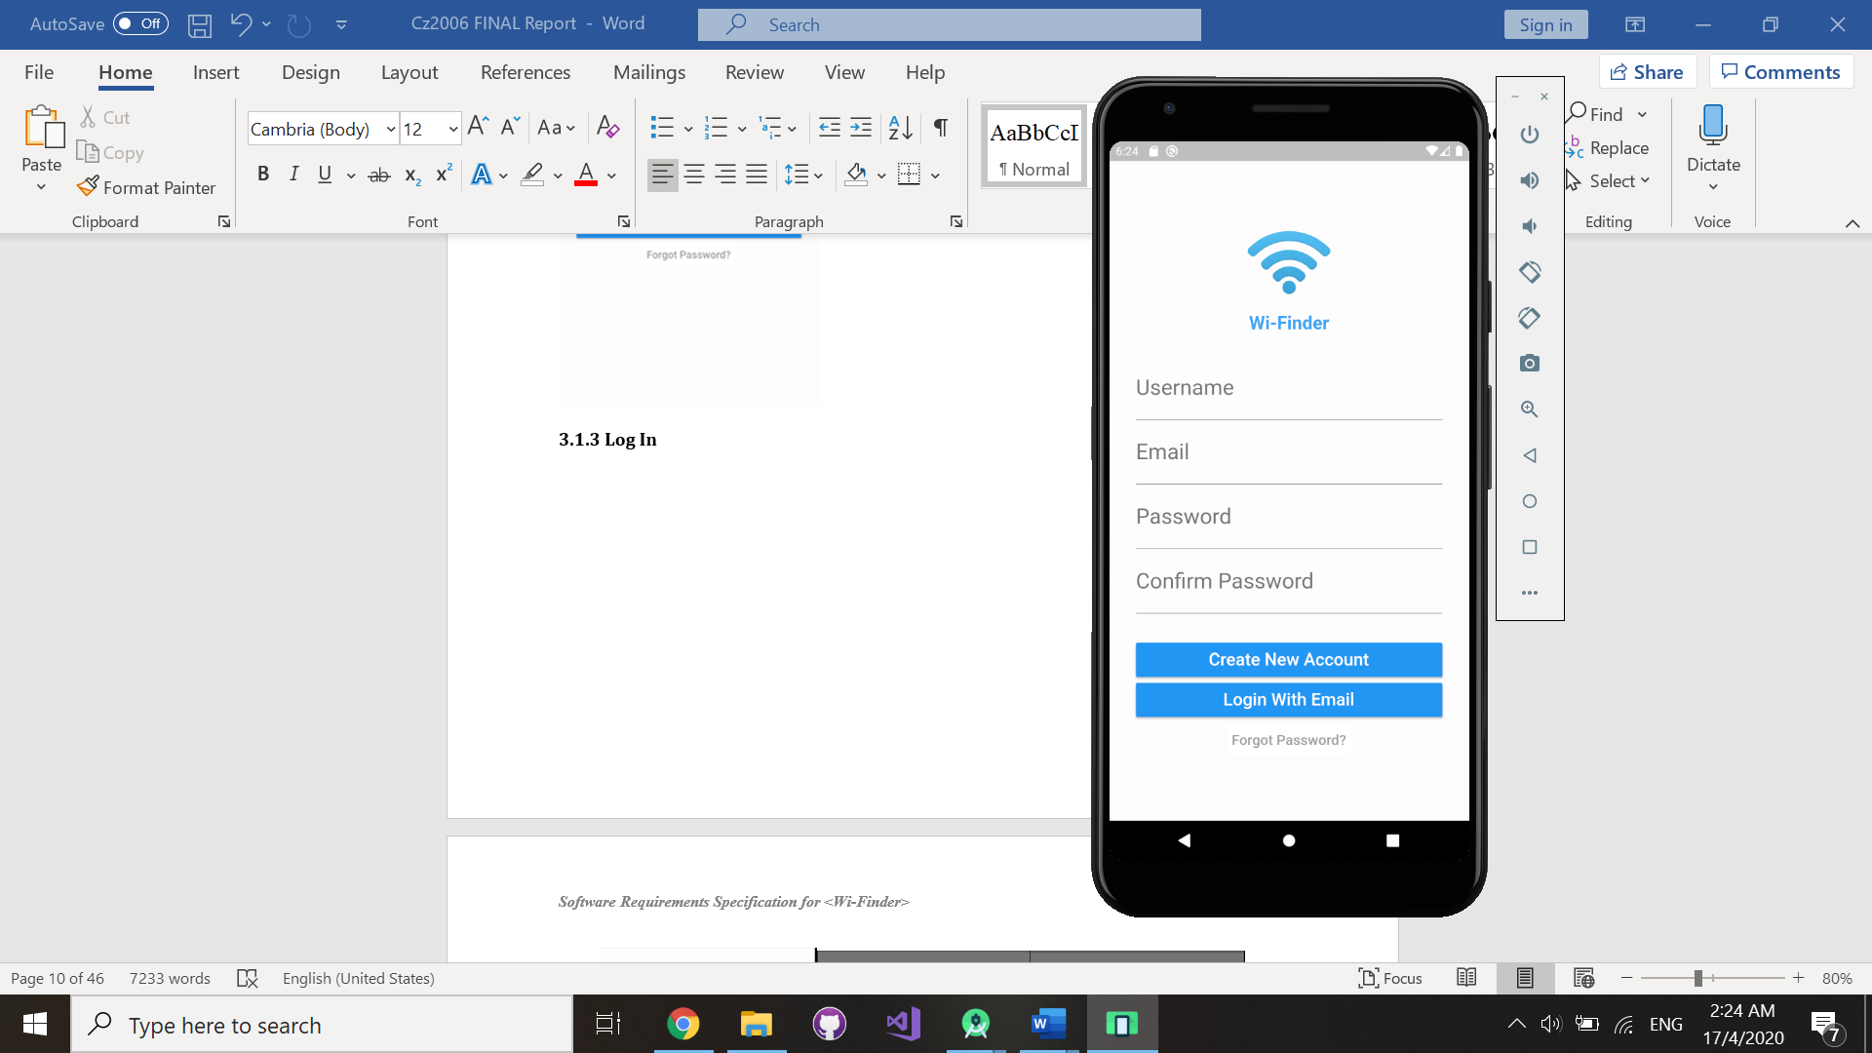

The Sign Up/Log In page is set as the application

landing page. Users are required to create an account with a valid email address before they can start using Wi-Finder. The application will prompt users to enable their Global Positioning System (GPS) and allow access to their geographic location.

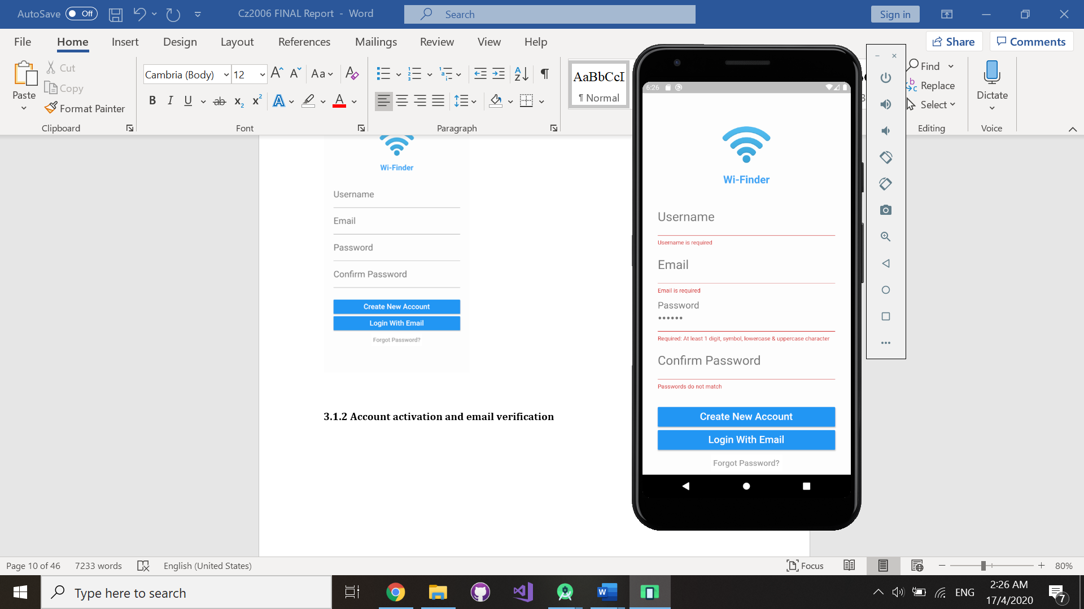

Users must satisfy all text fields validations

put in place to create a Wi-Finder account.

### 3.1.1 Sign Up

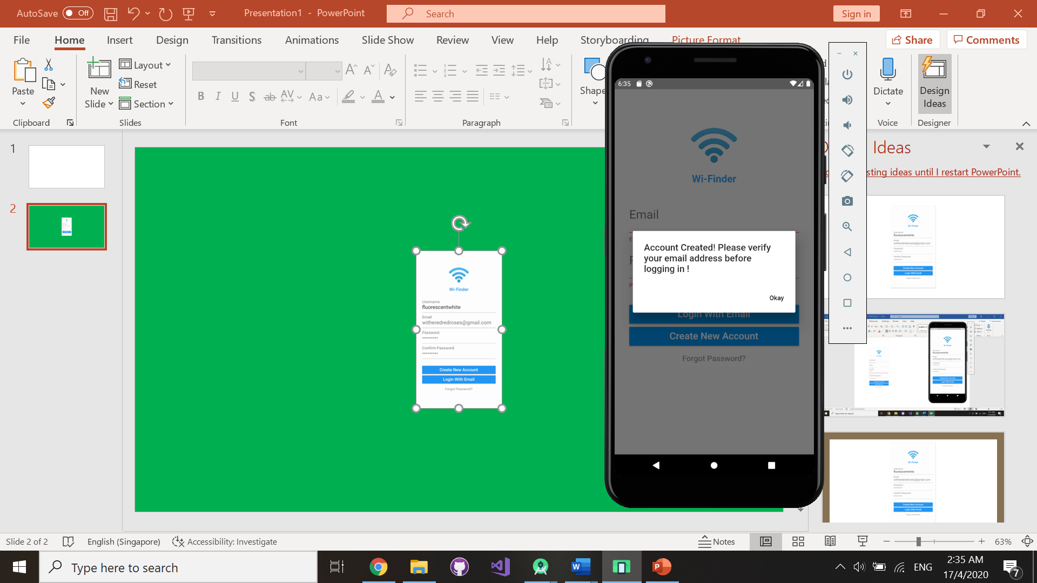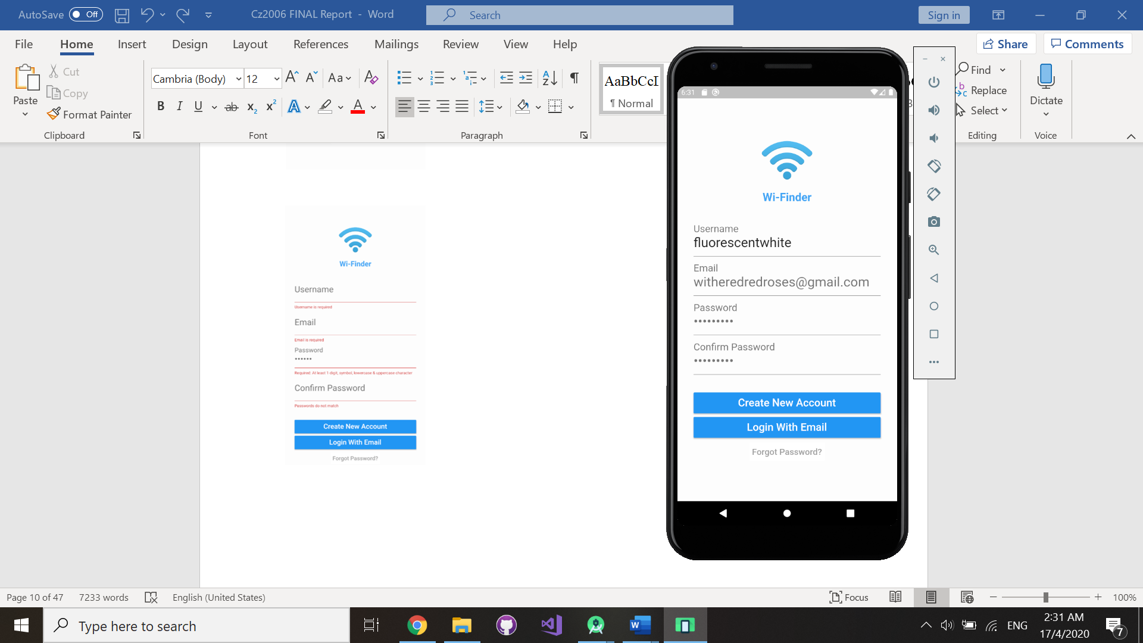

After the creation of an account, users are required to verify and activate their Wi-Finder account by following a link sent to their registered email address.

### 3.1.2 Account activation and email verification

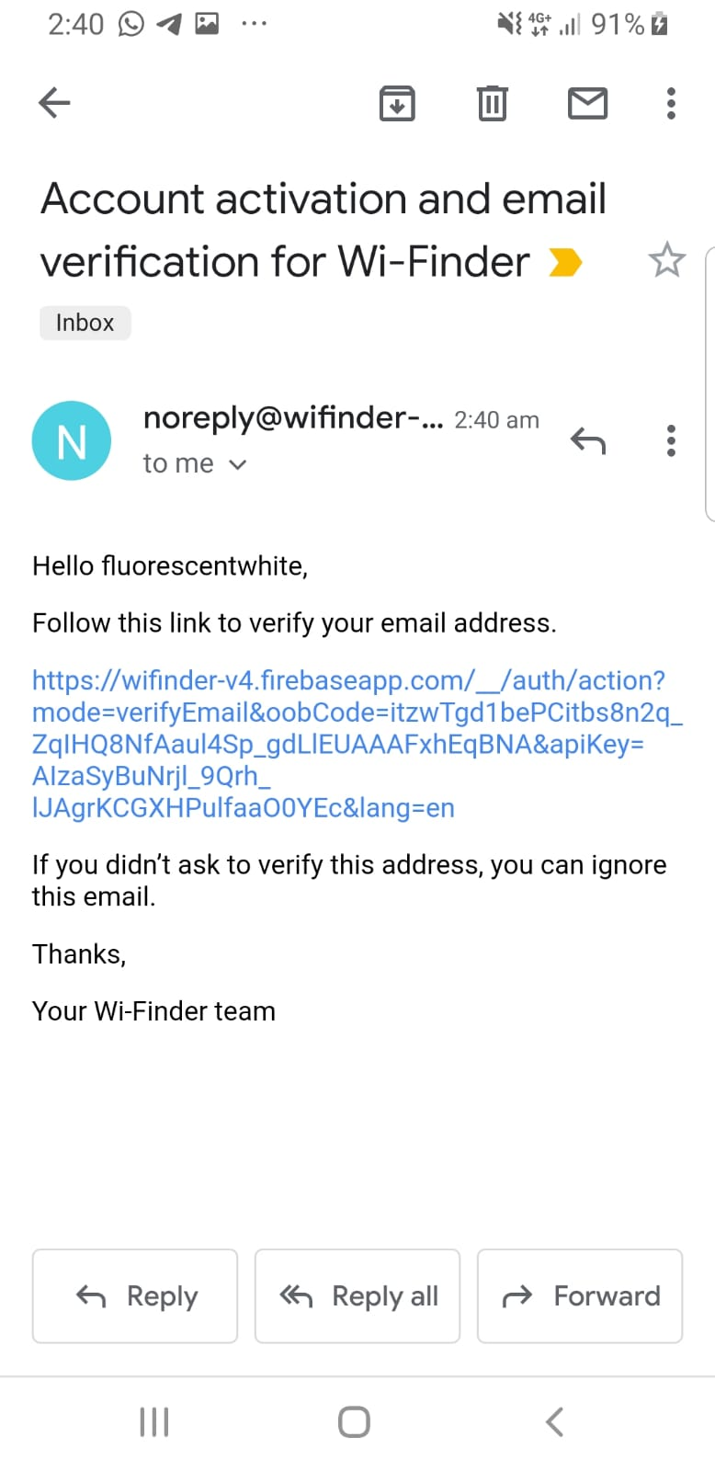

Wi-Finder account will be activated once

the user’s email account has been verified.

Users will be able to log in to their account

after completing this step.



### 3.1.3 Log In

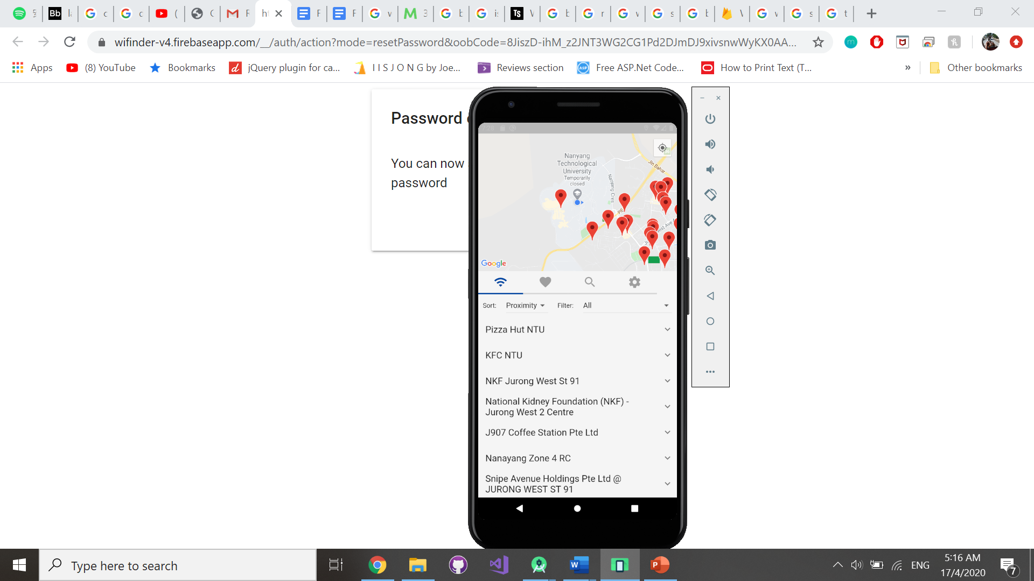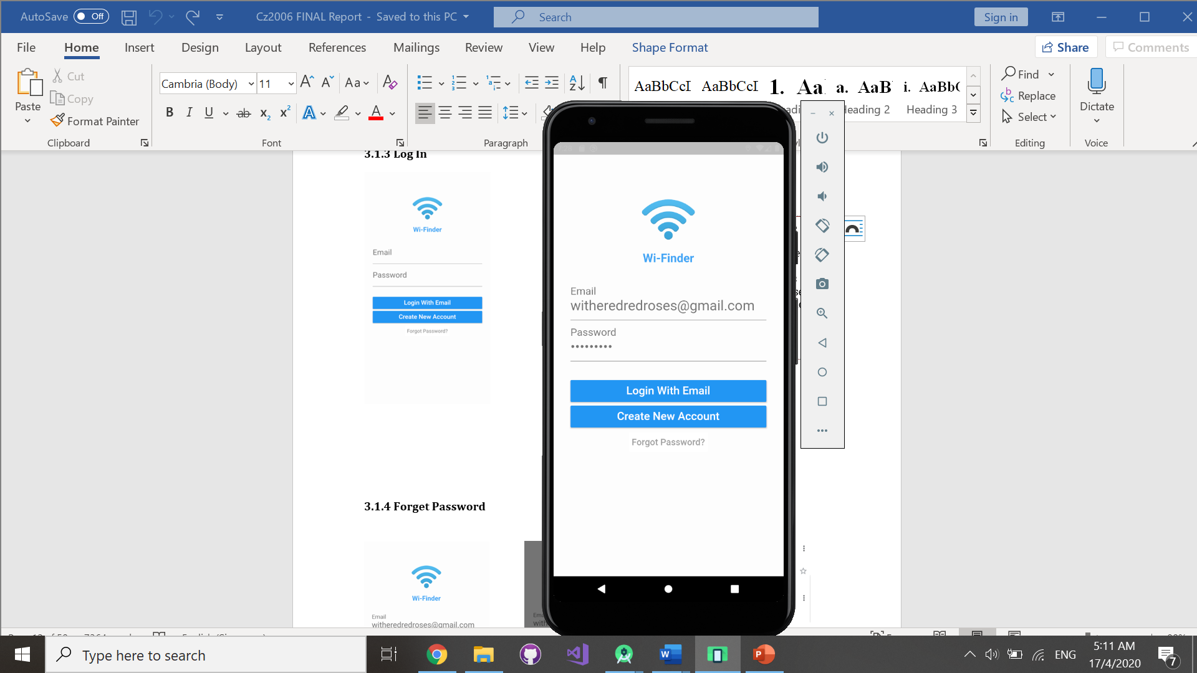

Users will be redirected to Wi-Finder’s homepage after logging in with a valid email address and password.

### 3.1.4 Forget Password

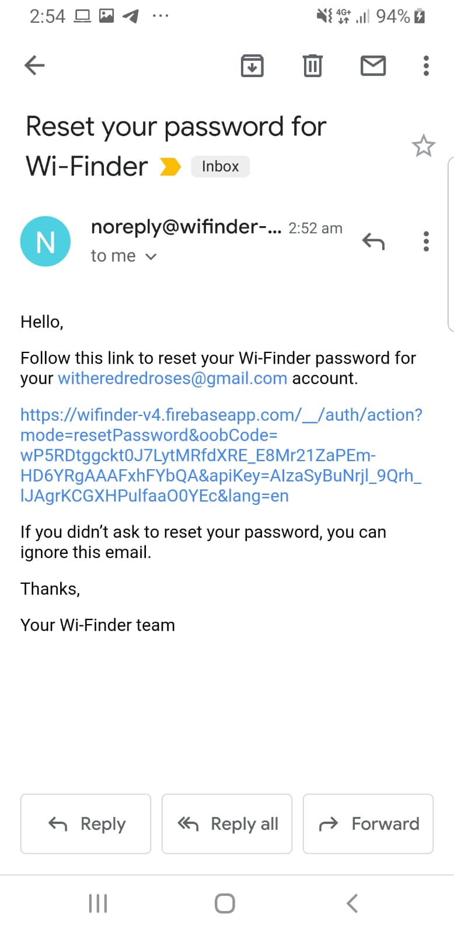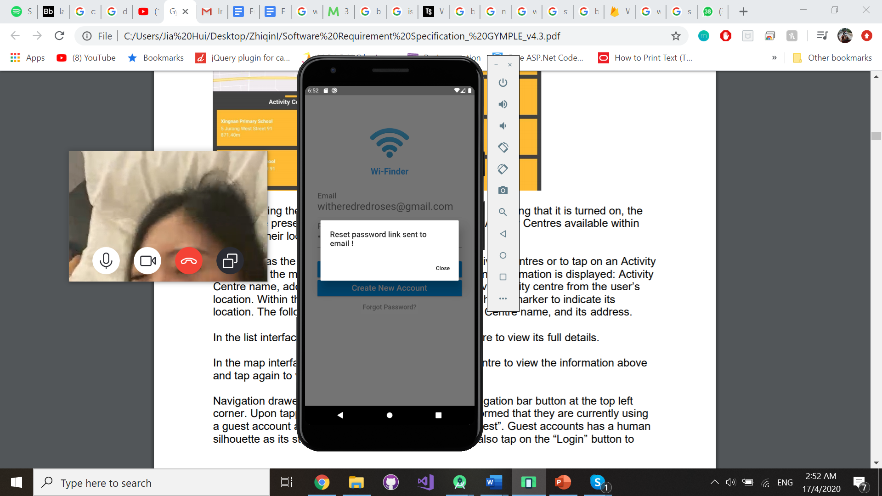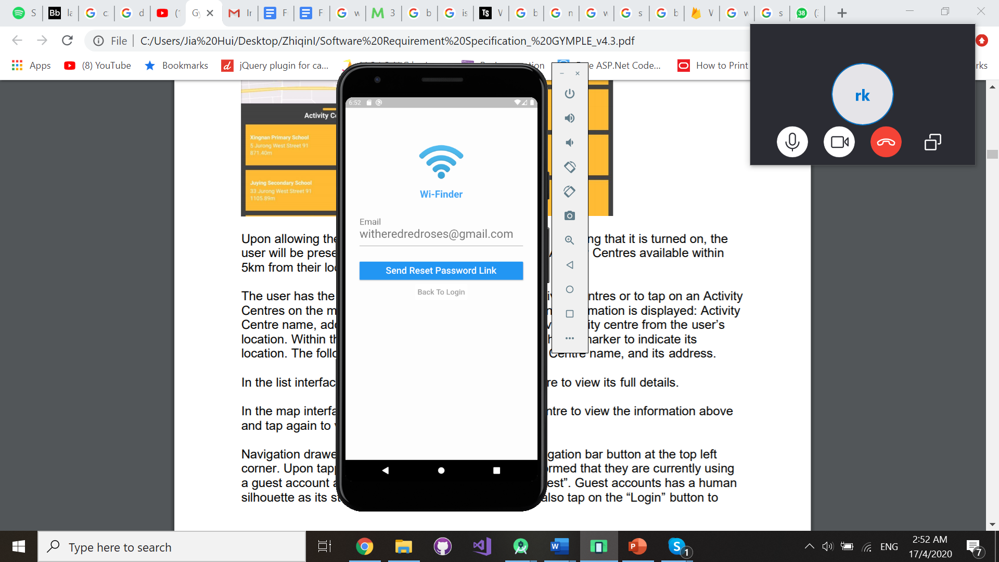



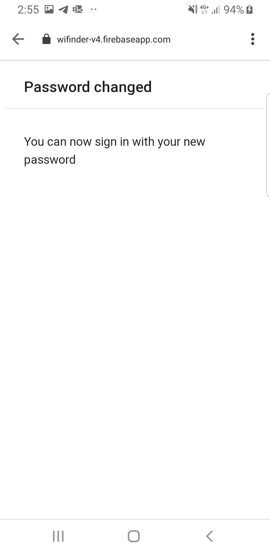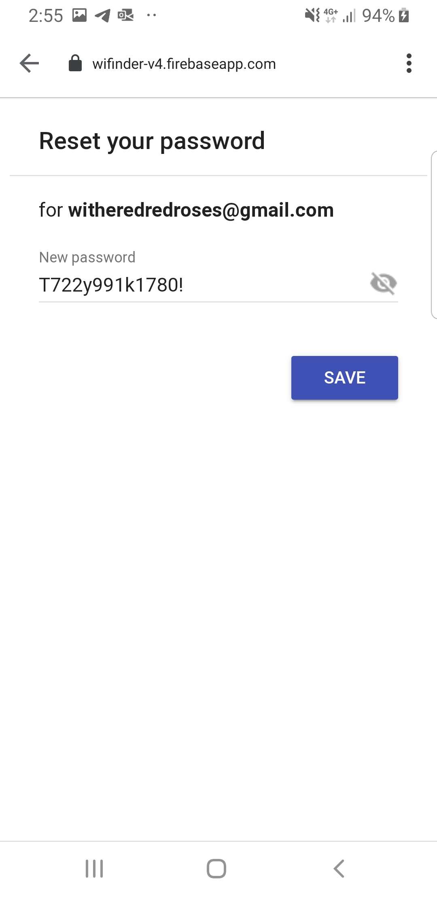



In an event where the user forgets their account password, they will be able to request for a password change. The reset link will be sent to their registered email address.

### 3.1.5 View Wi-Fi hotspots details

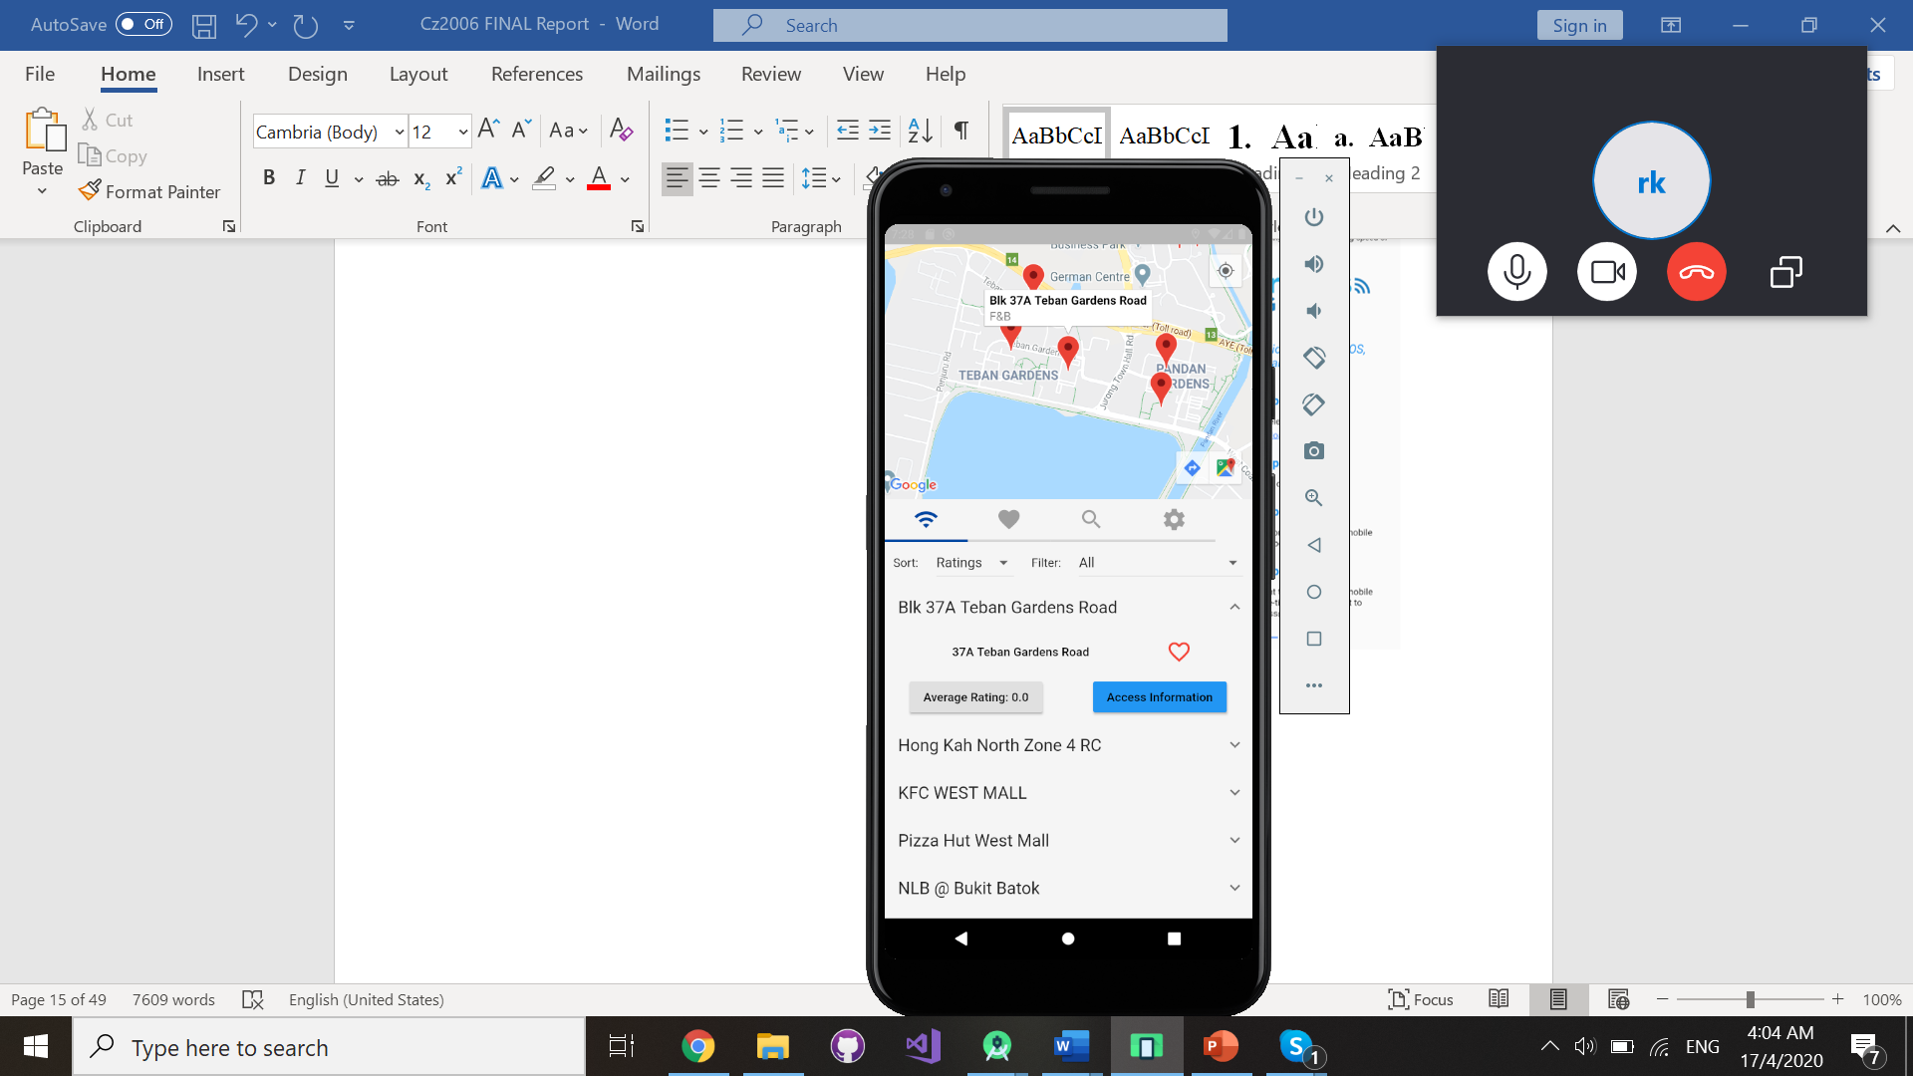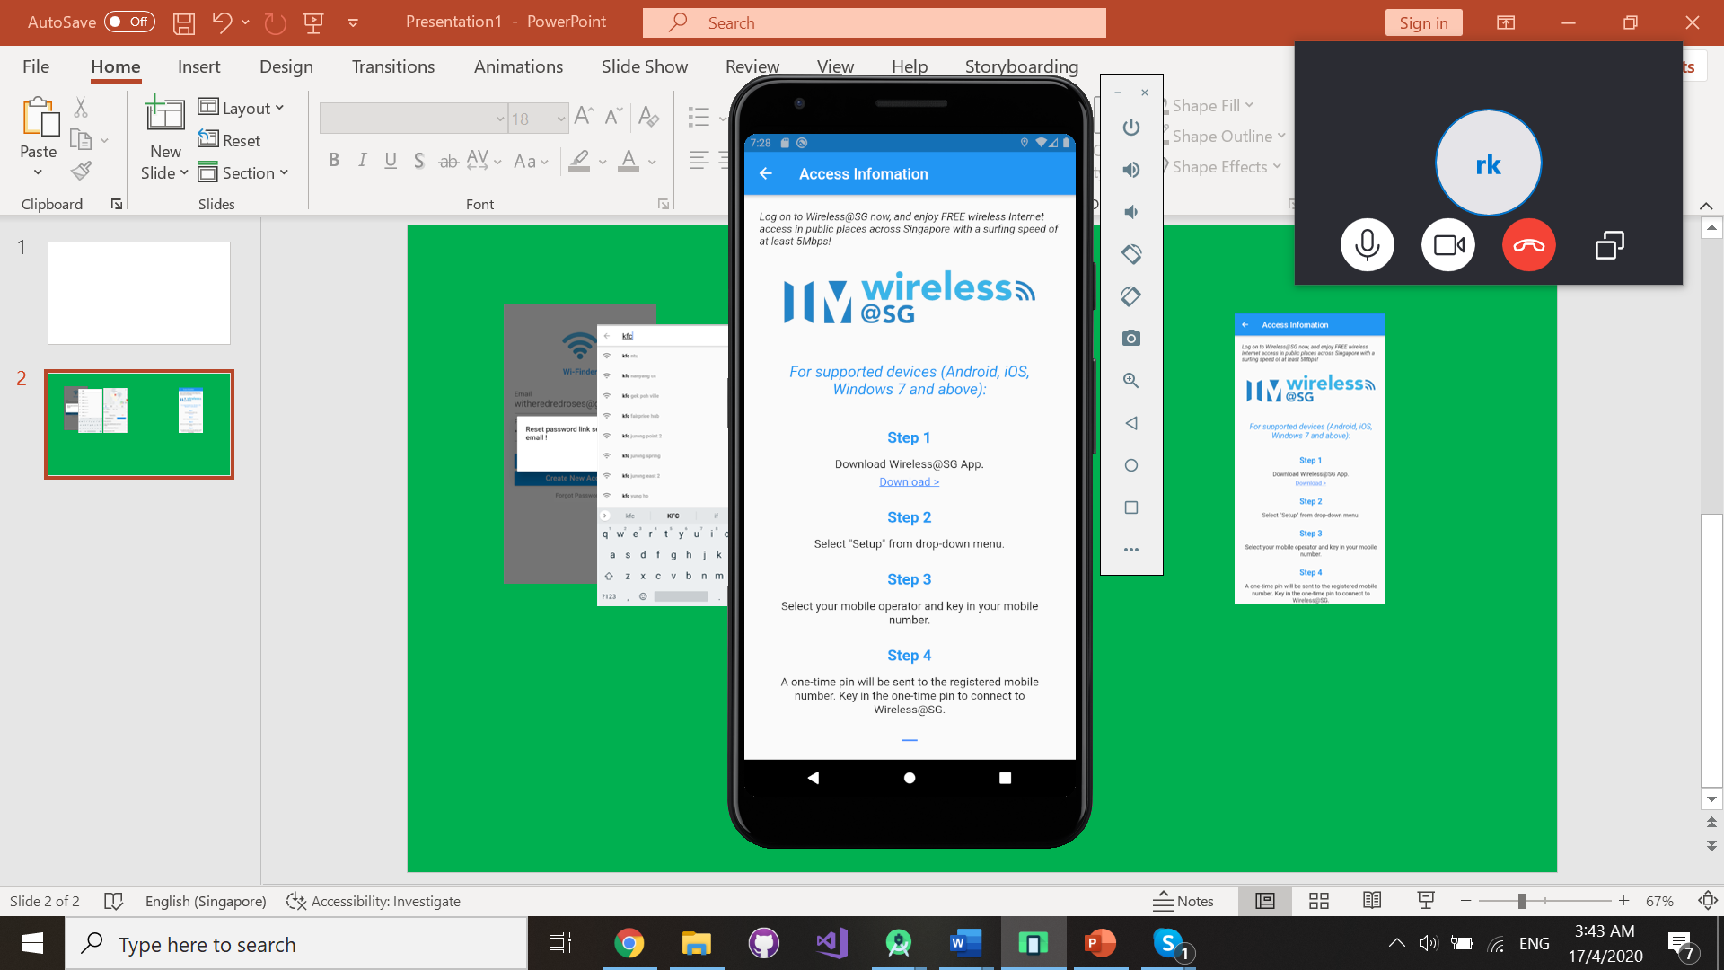

Users will be redirected to Wi-Finder’s homepage after a successful log in. Users are presented with a map interface and a list of Wi-Fi hotspots available. To view more information of a Wi-Fi hotspot, users have the option to select from the list of Wi-Fi hotspots or to tap on any Wi-Fi hotspots markers on the map.

Within the list interface, the following information is displayed: Wi-Fi hotspot’s name, address, favourite status as well as access information. In the list interface, users can tap on Wi-Fi hotspots to view its full details.

Within the map interface, each Wi-Fi hotspot has a marker to indicate its location. The following information is displayed: Wi-Fi hotspot’s name and location type. In the map interface, users can tap on Wi-Fi hotspots to view the information listed above and tap again to view its full details.

### 3.1.6 Search and Navigation Interface

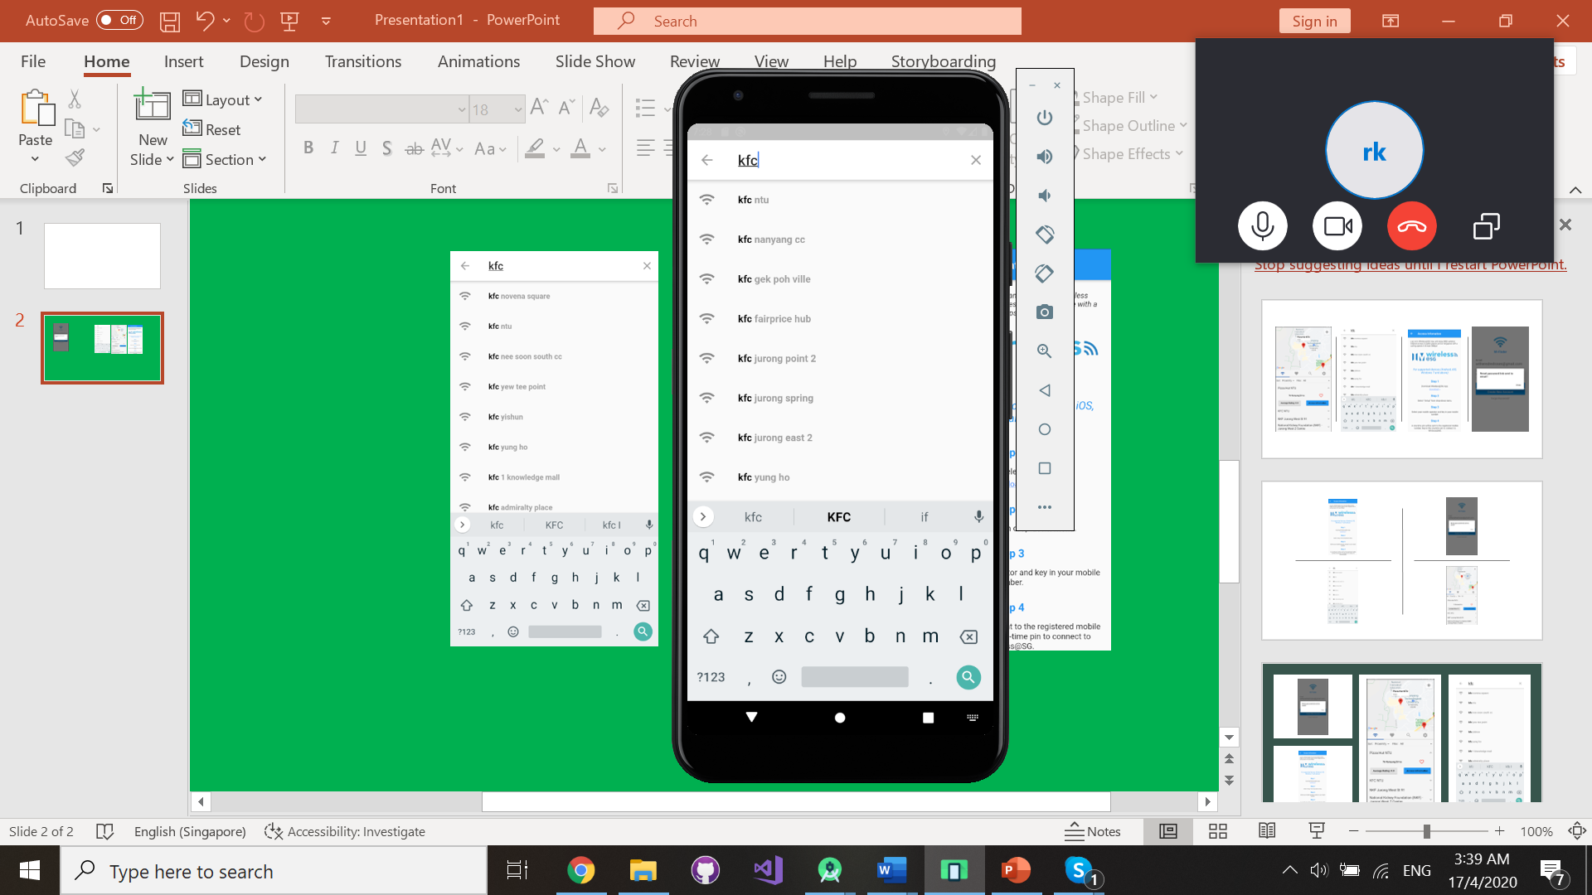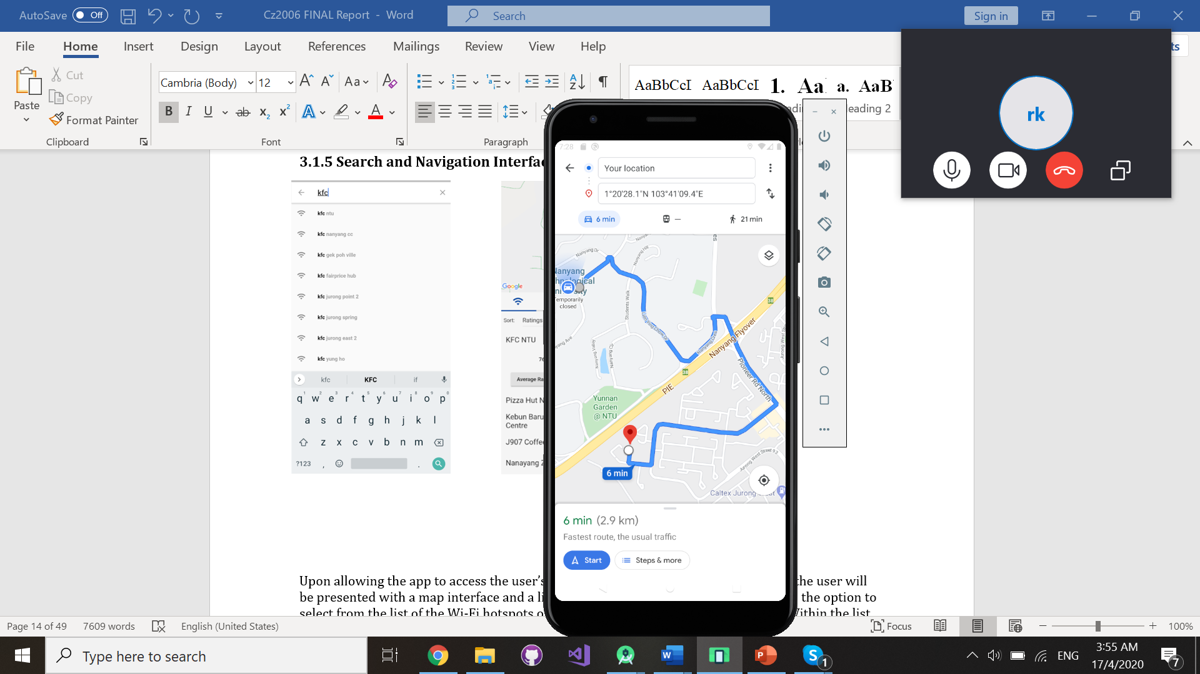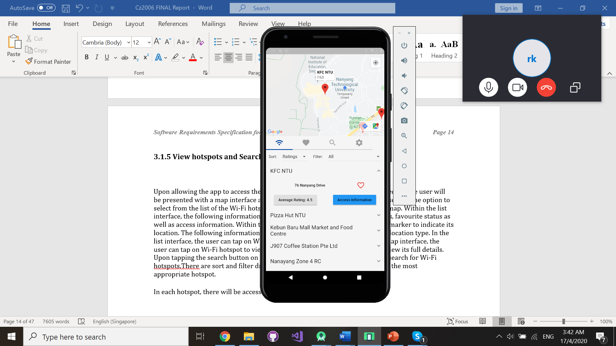



Users will be able to search for Wi-Fi hotspots by tapping on the search icon on the menu bar. To start navigating, users simply need to tap on the google map icon.

### 3.1.7 Filter and Sort Wi-Fi hotspots by preference

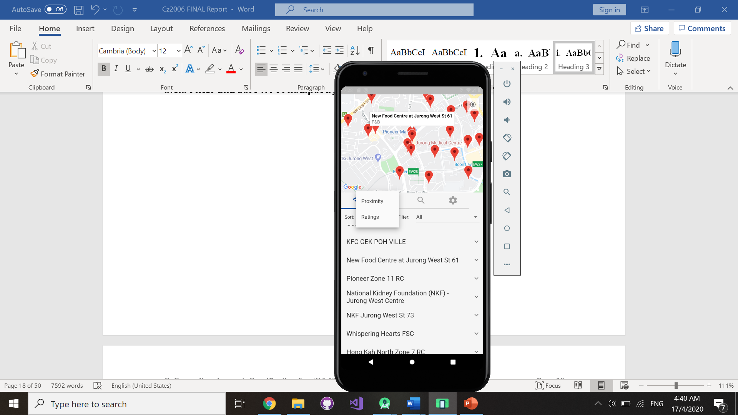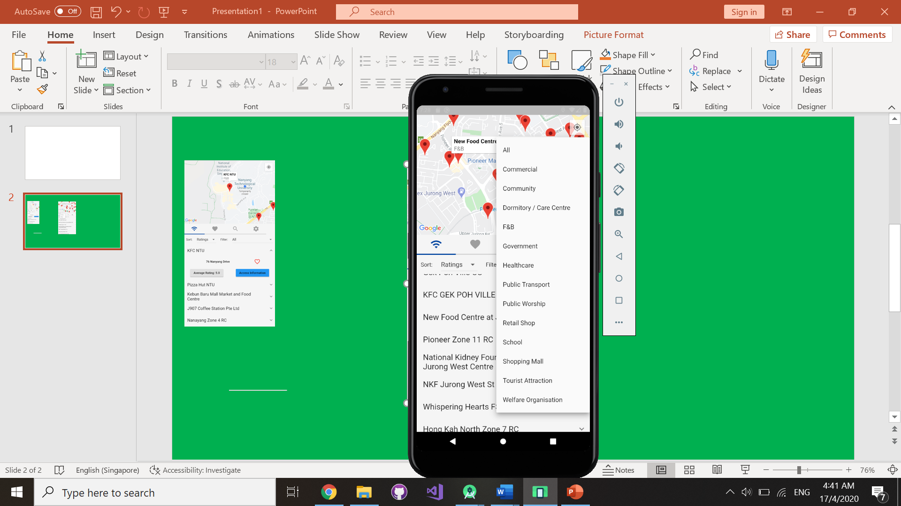

Users will be able to use dropdown menus to filter and sort Wi-Fi hotspots by preference.

### 3.1.8 Reviews and Ratings

Create review and rating:

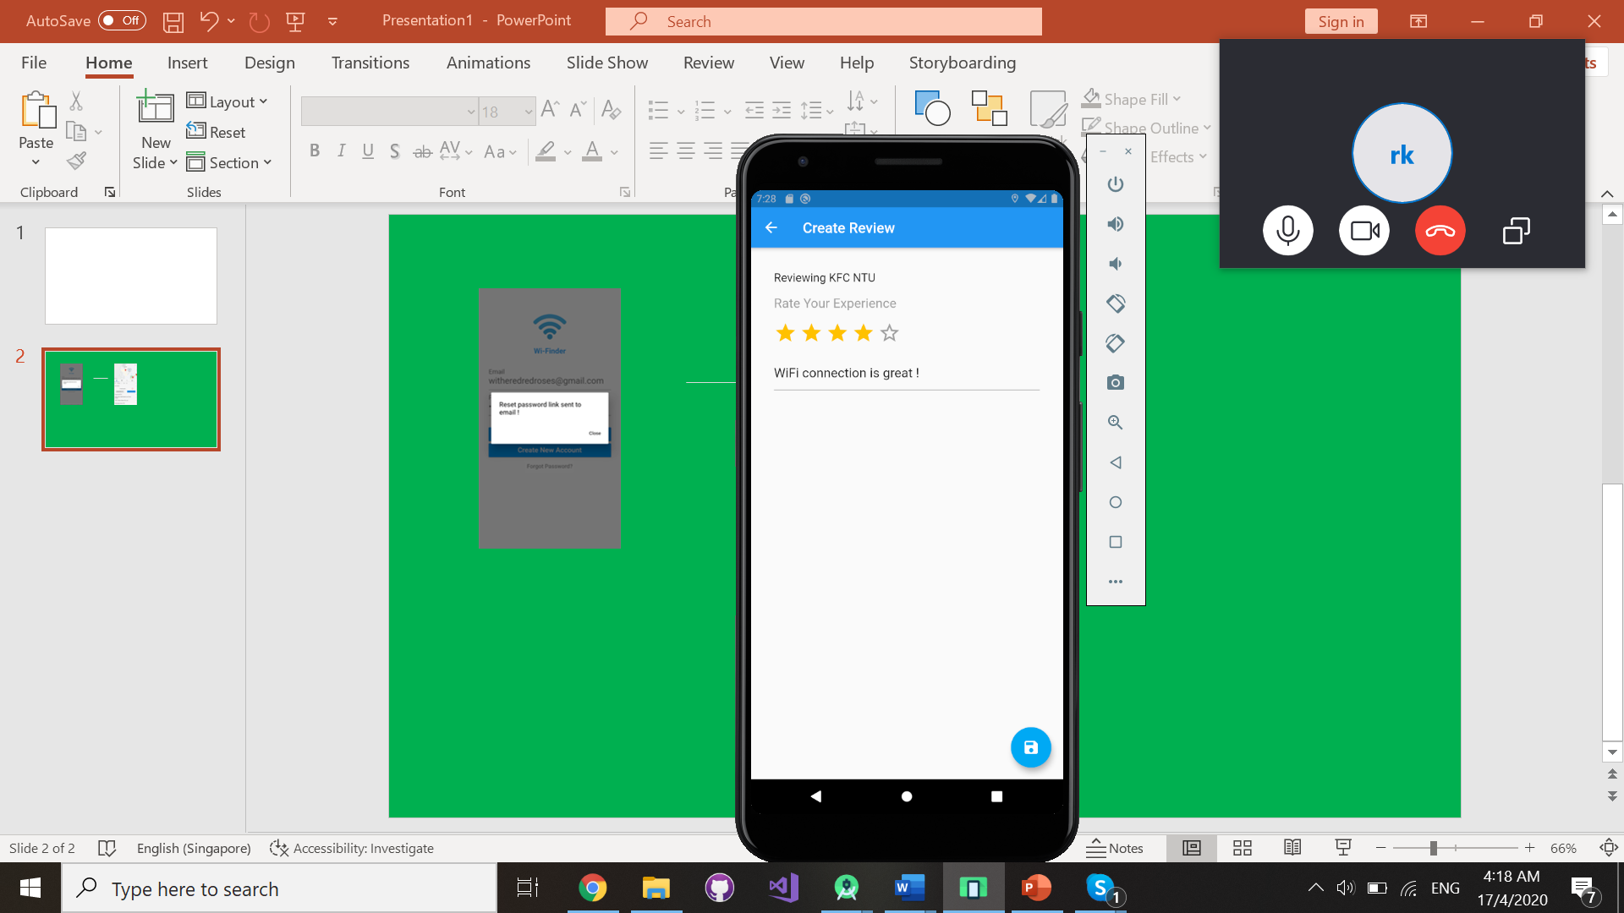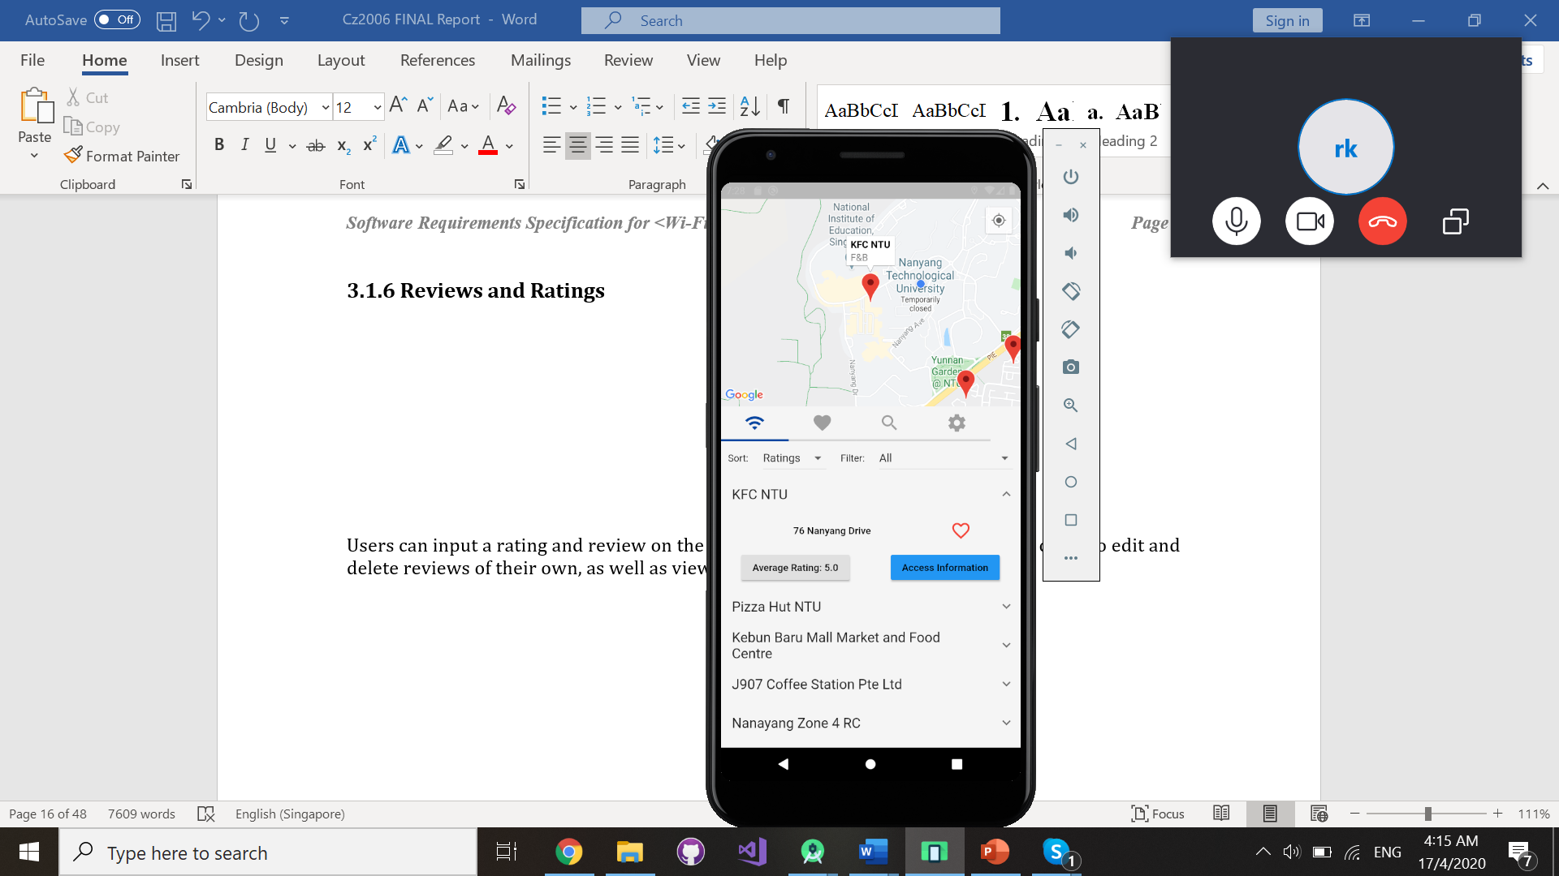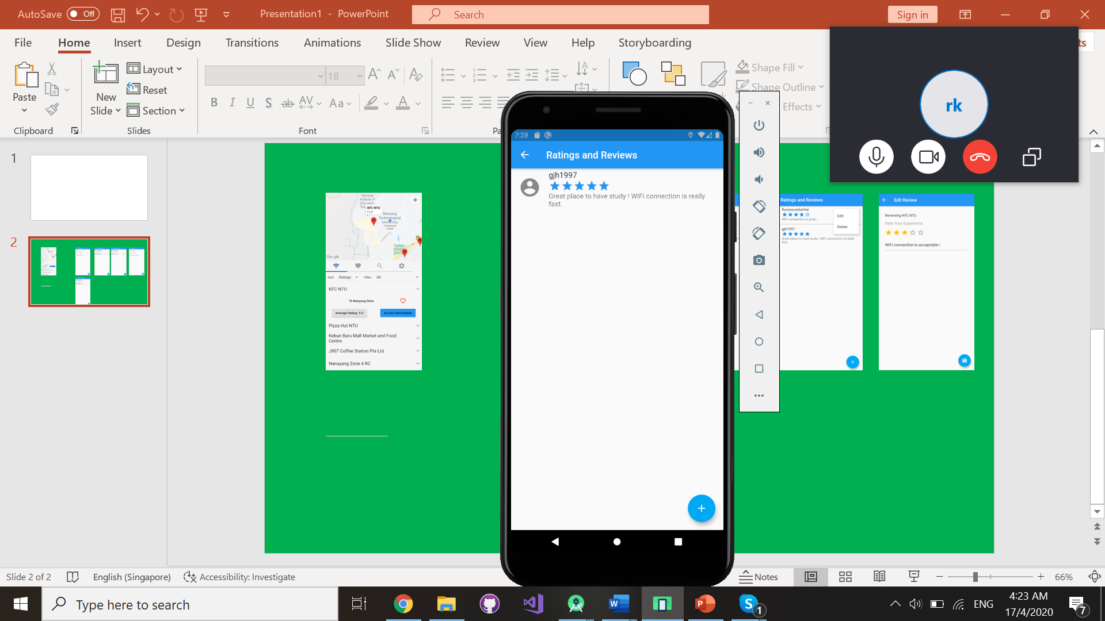



Edit review and rating:

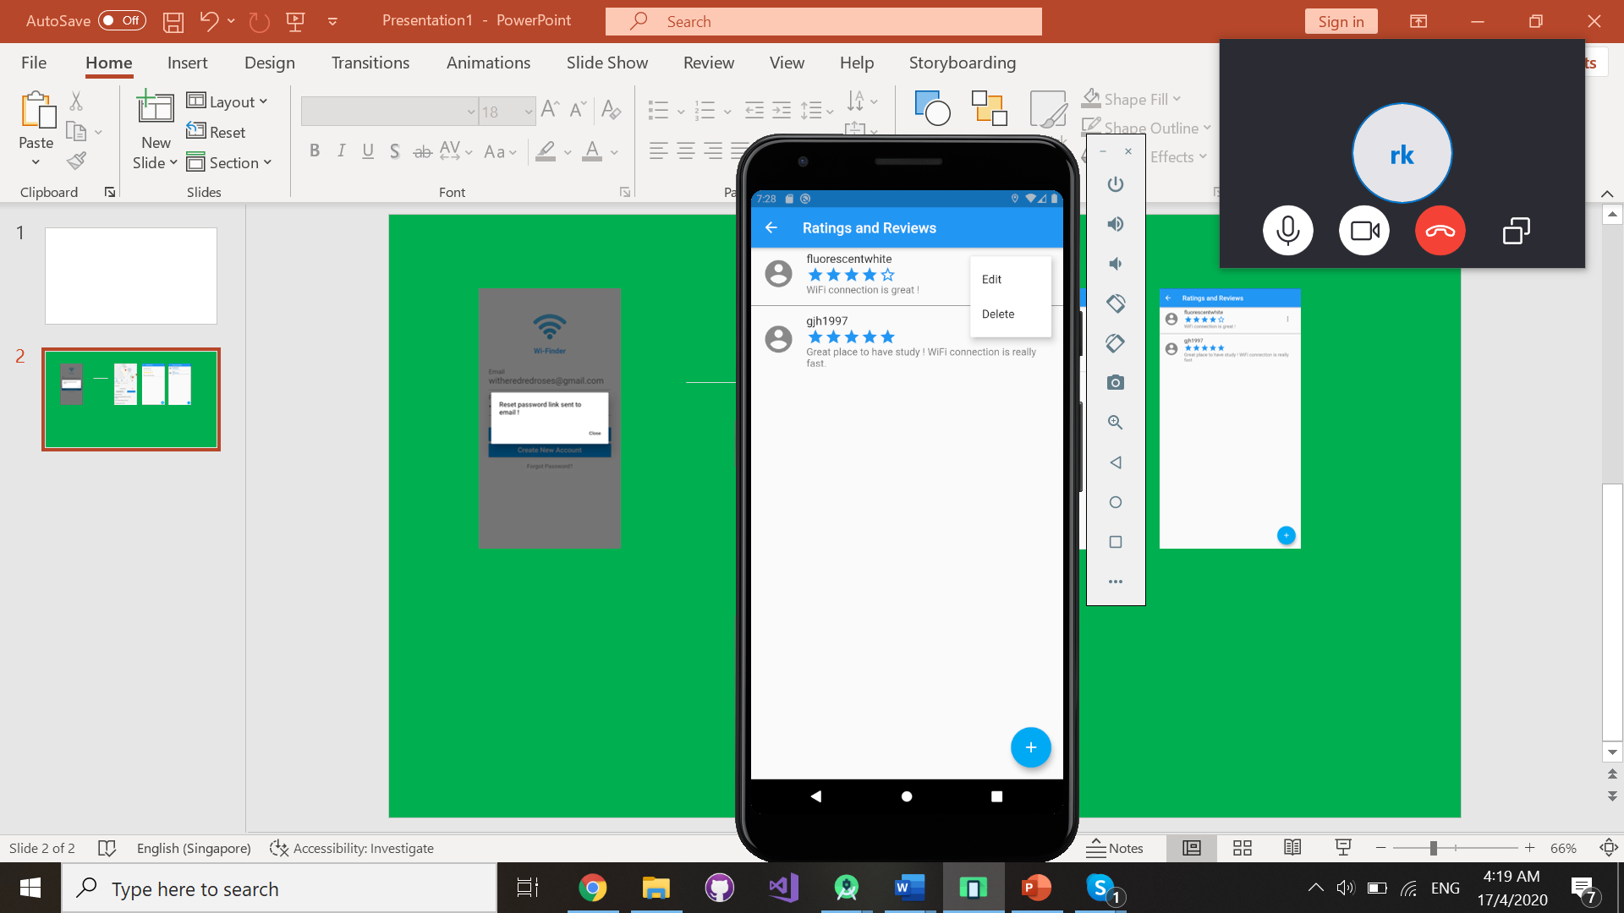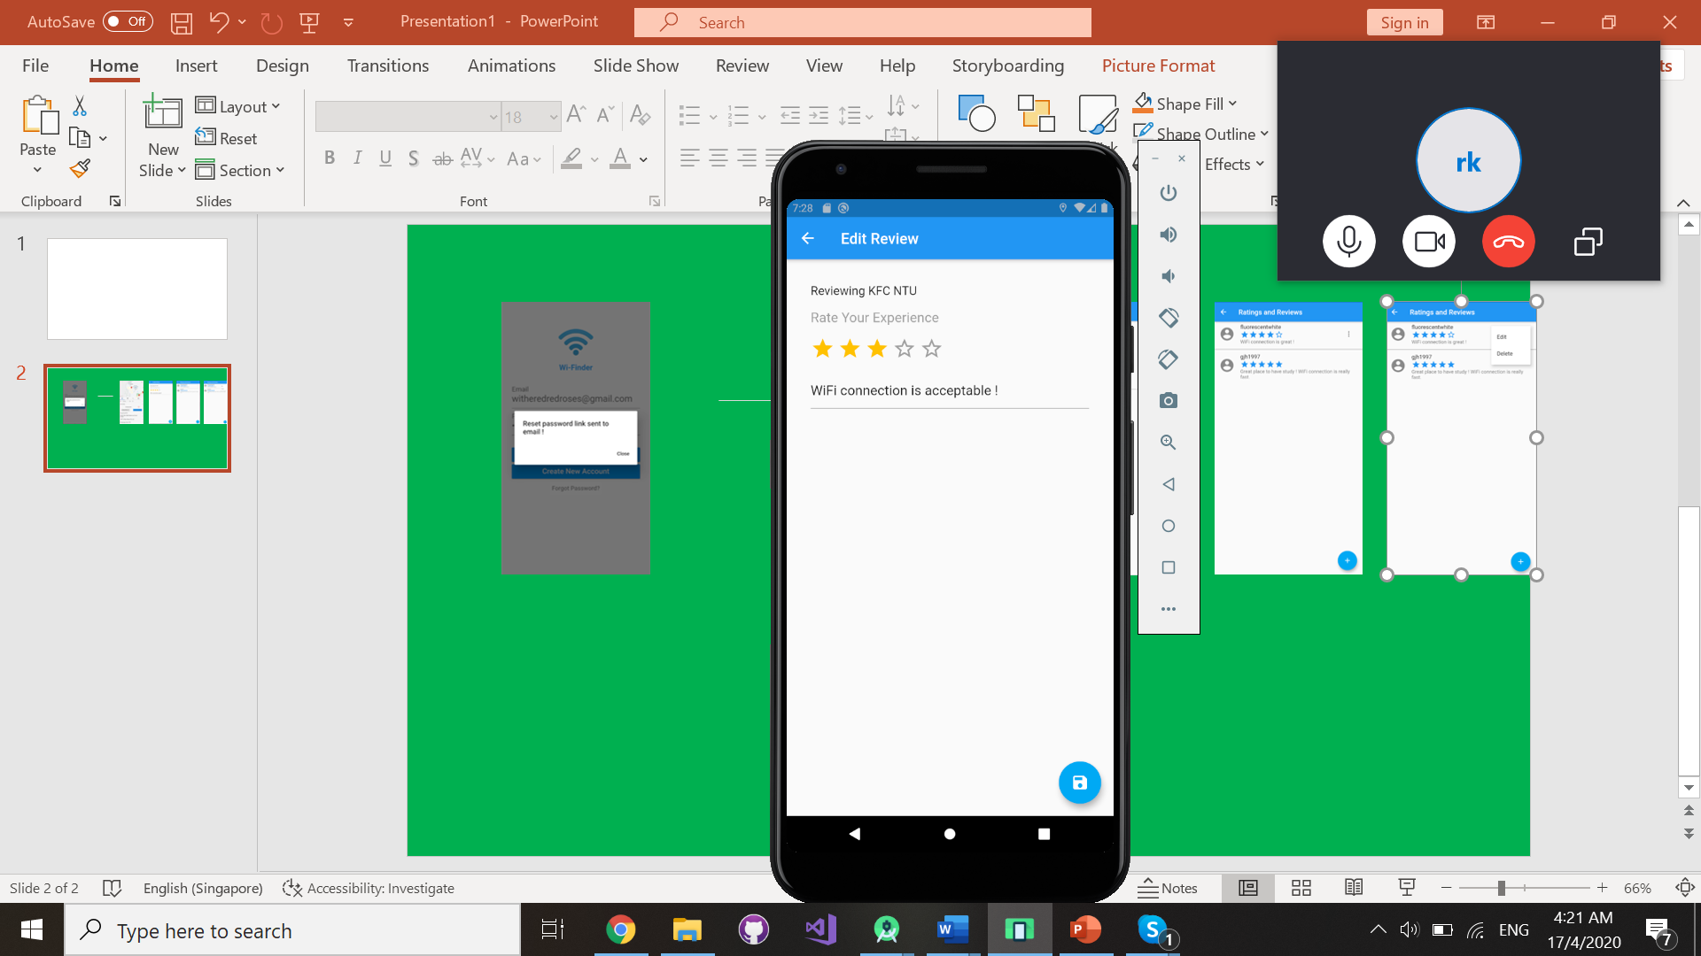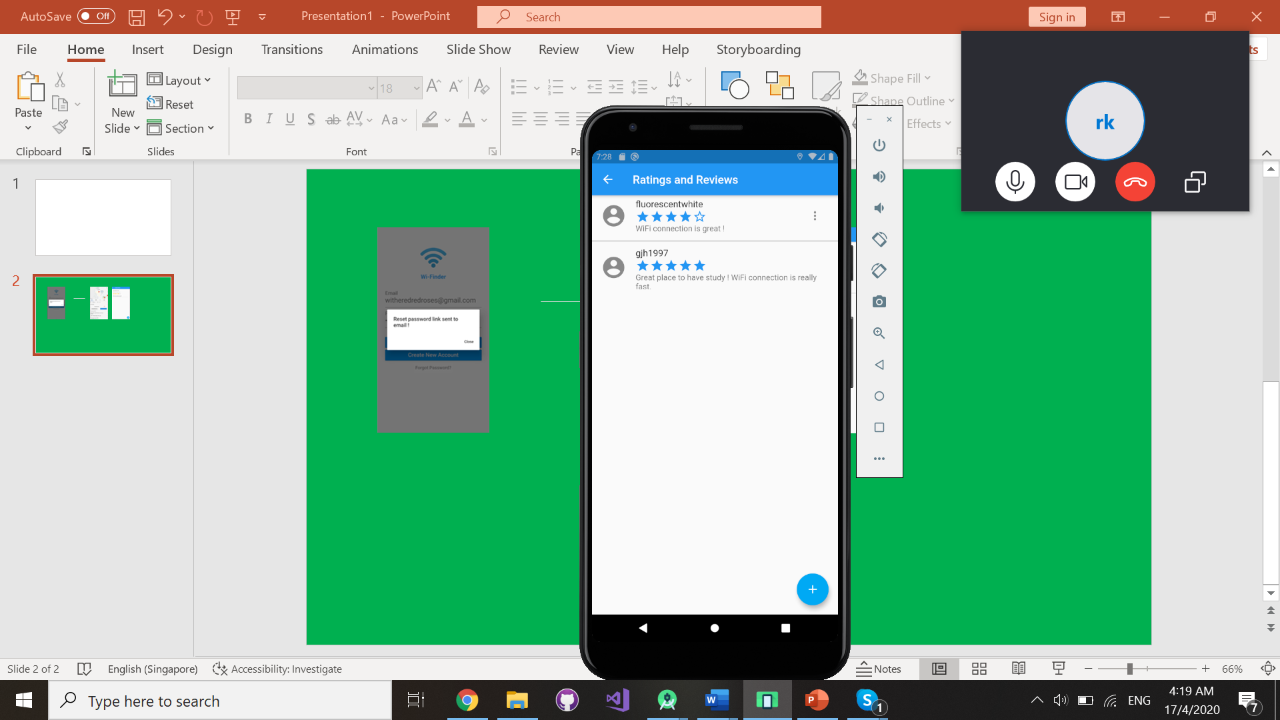





### 3.1.9 Reviews and Ratings

Delete review and rating:

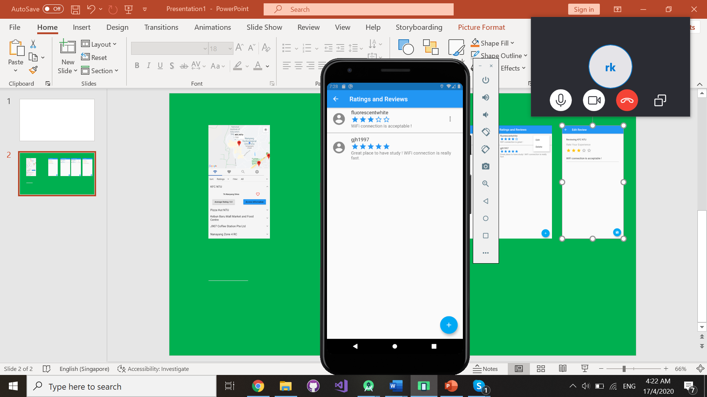





Users will be able to view reviews and ratings left by other users and to create, view, edit and delete their own reviews and ratings.

### 3.1.10 Bookmark Wi-Fi hotspot as favourite

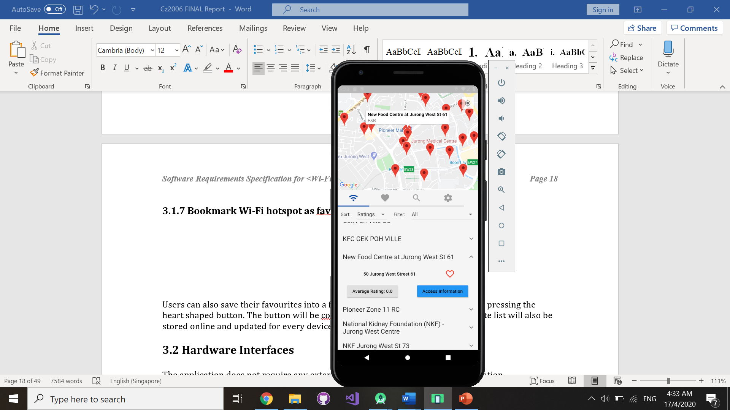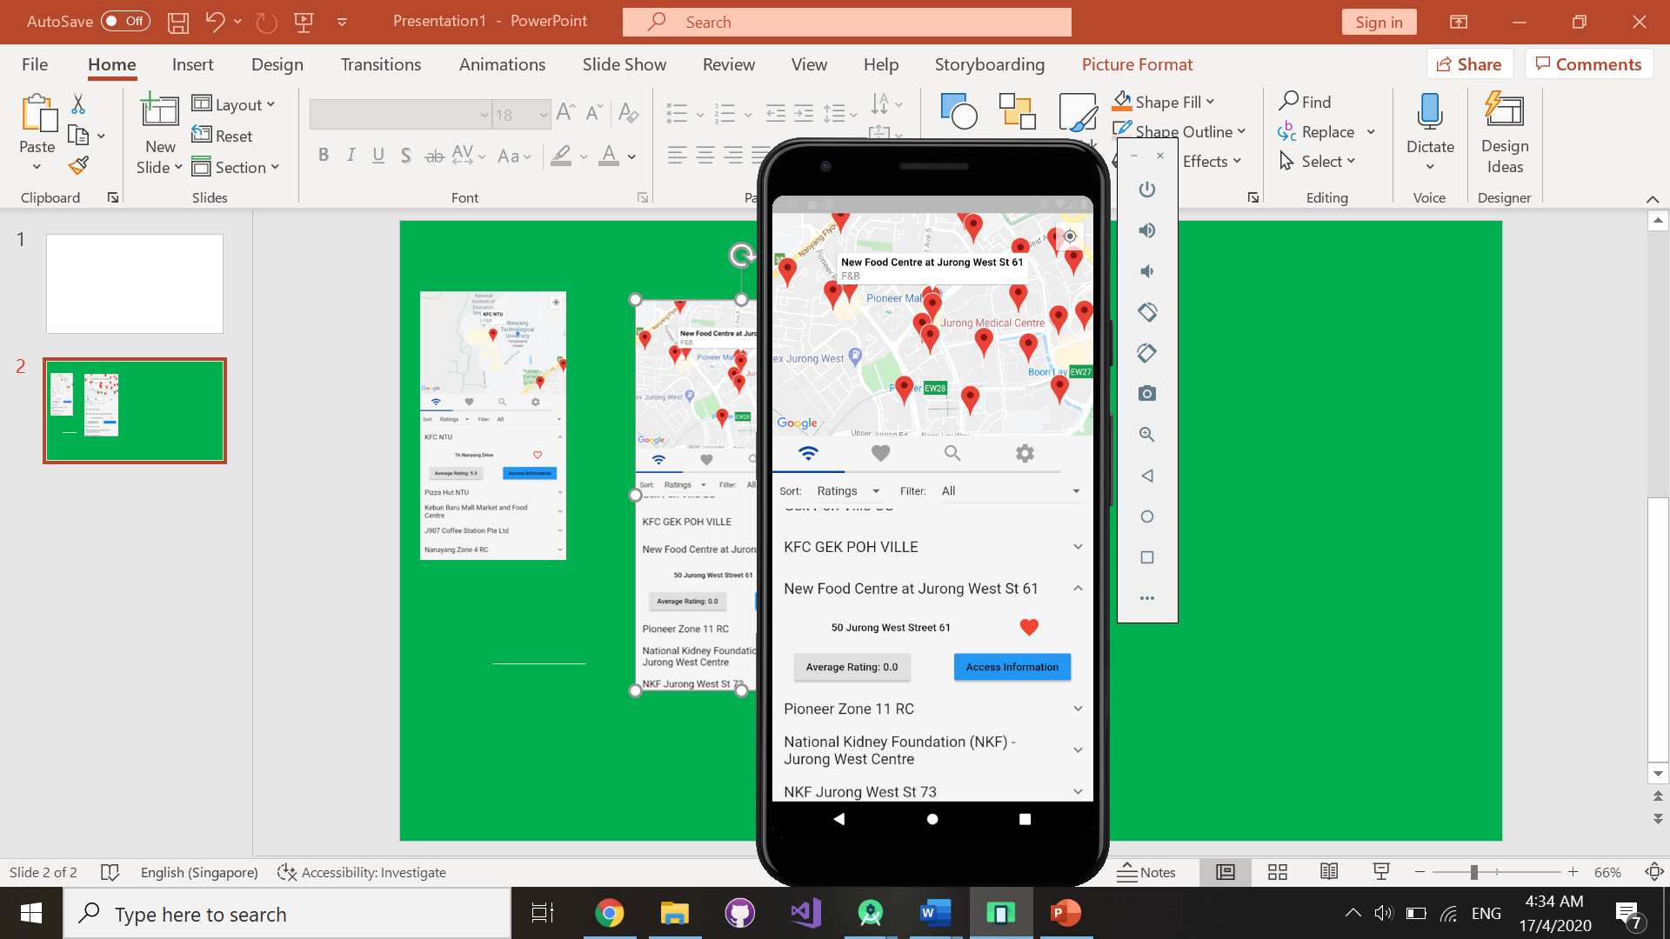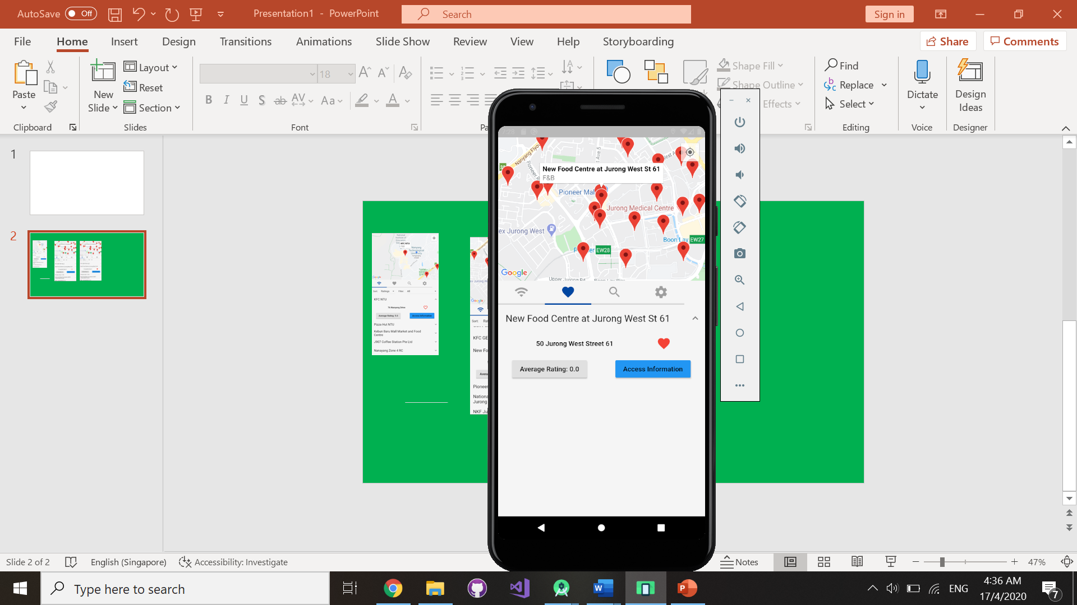



Users will be able to bookmark their frequently accessed Wi-Fi hotspots as a favourite for easy access.

## 3.2 Hardware Interfaces

The application does not require any external hardware devices to run the application.

## 3.3 Software Interfaces

### 3.3.1 Cloud Firestore Authentication (Account Activation and Email Verification)

After the creation of a Wi-Finder account, users will be prompted to activate their account by verifying the validity of their email address. Users who did not verify their email address will be prompted to do so when they attempt to log in with their account.

### 3.3.2 Cloud Firestore Authentication (Forget password)

In the event where the user forgets their account password, they will be able to request for a password change by entering their registered email address. A password reset link will be sent to their email address.

### 3.3.3 Firebase Cloud Firestore

All Wi-Finder’s users’ profile information and account activity such as created reviews and ratings and Wi-Fi hotspots bookmarked as favourites are stored in Firebase Cloud Firestore.

### 3.3.4 Google Geocoding API

Upon selecting a Wi-Fi hotspot from the Map and List view, the name and latitude/longitude of each Wi-Fi hotspot provided in the KML data is parsed into the Google Geocoding API to retrieve a unique place ID of each Wi-Fi hotspot. The place ID is retrieved in the form of a JSONArray and stored in a JSONObject. If there are multiple place IDs available, the first place ID will be selected as the Wi-Fi hotspot place ID.

### 3.3.5 Google Maps API

Wi-Finder uses Google Maps API to retrieve the approximate location of the user’s device.

### 3.3.6 Android Operating System

We have chosen to run the application on the Android Operating System as it is the most popular and widely used mobile operating system. This will allow us to market our product to more users.

### 3.3.7 Flutter SDK

The Flutter Software Development Kit v1.12.13 is used due to its simple UI design, extensive support and ease of cross platform development.

## 3.4 Communications Interfaces

Wi-Finder uses internet connection along with internet protocol to access users’ profile information from Firebase Cloud Firestore. The Firebase API returns the user’s profile information.

# 4. System Features

## 4.1 View Wi-Fi hotspots

### 4.1.1 Description and Priority

The user will be able to view nearby Wi-Fi hotspot locations and information about them.

Priority: High

### 4.1.2 Stimulus/Response Sequence

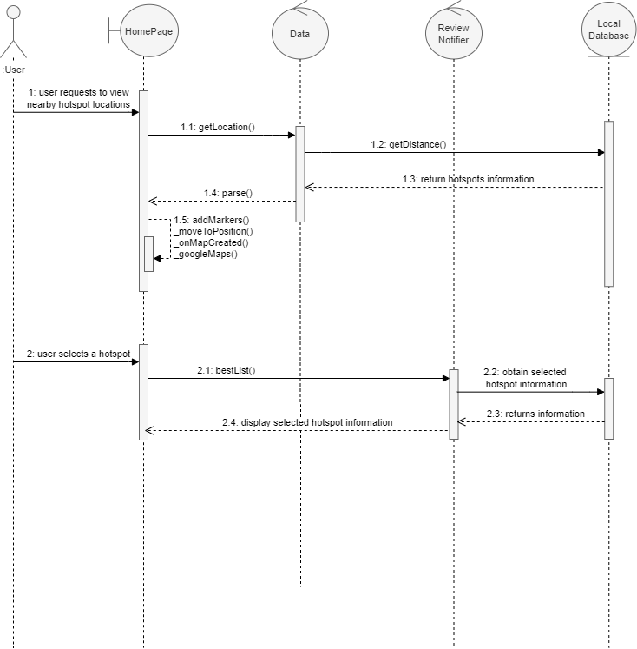

|  |  |
| --- | --- |
| **Stimulus** | **Response** |
| User opens the home page | * The system will list out all nearby Wi-Fi hotspots. * The system will show an interactable map of the nearby surroundings, with pins indicating the hotspot locations. |
| User taps on a Wi-Fi hotspot on the list | * The system will display the selected hotspot’s address, average rating, access information and favourite indicator. |

### 4.1.3 Functional Requirements

|  |  |
| --- | --- |
| REQ 1-1:  Location Service and Internet Access | 1. Location services need to be turned on to view nearby hotspot locations. 2. If location services are turned off, system will display all Wi-Fi hotspots in the local database. |
| REQ 1-2:  View map of nearby surroundings | 1. The application must display a map of the surrounding location. 2. The hotspot location must be marked with a pin on the map. 3. The user must be able to interact with the map. 4. The user must be able to zoom in and out of the map. 5. The user must be able to drag the map to view the surrounding locations. 6. The user must be able to tap on any of the pins to view more information of the hotspot. 7. The user must only be able to select one pin at a time. |
| REQ 1-3:  View list of nearby hotspots | 1. The application must display a list of nearby Wi-Fi hotspots 2. By default, the list must be sorted by proximity. 3. The nearest hotspot location must be shown at the top of the list. 4. The user must be able to interact with the list. 5. The user must be able to scroll up and down the list. 6. The user must be able to tap on any hotspot and the list will expand to display information of the selected hotspot. |

## 4.2 Sort and Filter Wi-Fi hotspots

### 4.2.1 Description and Priority

The user will be able to sort and filter the Wi-Fi hotspot list.

Priority: Medium

### 4.2.2 Stimulus/Response Sequence

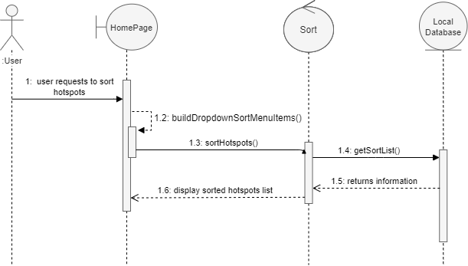

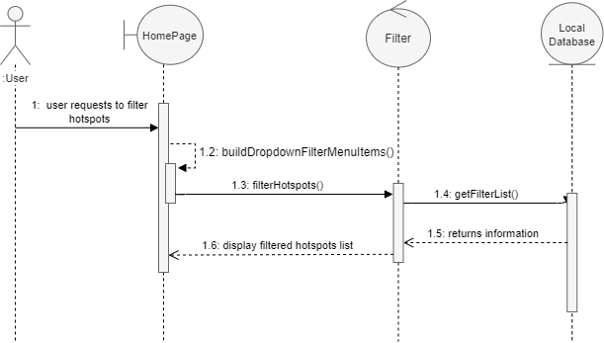

|  |  |
| --- | --- |
| **Stimulus** | **Response** |
| User taps on the ‘Sort’ button and selects a sorting method | * The application will display a drop-down menu showing all sorting methods. * After selecting a sorting method, the system must sort the hotspot locations accordingly and display the new sorted list on the home page. |
| User taps on the ‘Filter’ button and selects a filter | * The application will display a drop-down menu showing all filters. * After selecting a filter, the system must filter the hotspot locations accordingly and display the new filtered list on the home page. |

### 4.2.3 Functional Requirements

|  |  |
| --- | --- |
| REQ 2-1:  Sort hotspot list by user’s preference | 1. The application must display the hotspot list according to user’s sorting preference. 2. Proximity: The application must display the closest hotspot location at the top of the list. 3. Ratings: The application must display the highest-rated hotspot location at the top of the list. |
| REQ 2-2:  Filter hotspot list by location type | 1. The application must allow user to filter the hotspot list by location type. 2. The application must display the hotspot list based on the selected filter. 3. The application must display all location types if no filter is selected. |

## 4.3 Search for Wi-Fi hotspot Location

### 4.3.1 Description and Priority

The user will be able to search for Wi-Fi hotspots in the database based on search input provided by the user.

Priority: High

### 4.3.2 Stimulus/Response Sequence

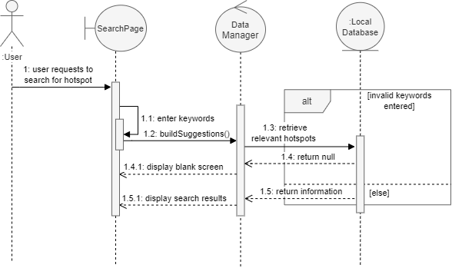

|  |  |
| --- | --- |
| **Stimulus** | **Response** |
| User requests to search for a Wi-Fi hotspot location | The system will process the keywords entered by the user and return a list of hotspot locations containing the keywords.   * If the keywords do not exist in any hotspot location, a blank list will be displayed. |

### 4.3.3 Functional Requirements

|  |  |
| --- | --- |
| REQ 3-1:  Search for Wi-Fi hotspot location | 1. User must be able to search for specific hotspot location(s) by entering keywords. These keywords include: 2. Location’s name 3. Location’s postal code 4. Location’s Address 5. The application must display the map view and list of hotspot locations based on the search. |

## 4.4 Favourite Wi-Fi hotspot Location

### 4.4.1 Description and Priority

The user will be able to bookmark their favourite hotspot locations and add them to a favourites list.

Priority: Medium

### 4.4.2 Stimulus/Response Sequence

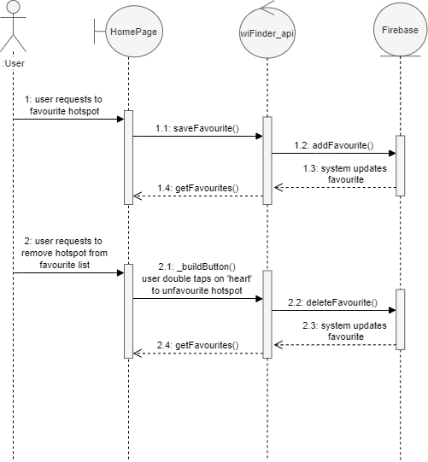

|  |  |
| --- | --- |
| **Stimulus** | **Response** |
| User taps on the grey heart icon on any hotspot location to favourite it | * The system will add the selected favourite hotspot location to the favourites list. * The grey heart icon will turn red. |
| User taps on the red heart icon to un-favourite hotspot location | * The system will remove the selected hotspot location from the favourites list. * The red heart icon will turn grey. |

### 4.4.3 Functional Requirements

|  |  |
| --- | --- |
| REQ 4-1:  Heart icon changes colour based on its favourite status | 1. The heart icon must turn from grey to red if the user favourites the hotspot location. 2. The heart icon must turn from red to grey if the user un-favourite the hotspot location. |
| REQ 4-2:  Add or remove hotspot locations from the favourites list | 1. The application must display all favourite hotspot locations in the favourites list. 2. The favourites list must be sorted from the most recently added to the least recently added. 3. The most recently favourite hotspot location must be at the top of the list. 4. The user must be able to interact with the list. 5. The user must be able to scroll up and down the list. 6. The user must be able to tap on any hotspot and the list will expand to display information of the selected hotspot. |

## 4.5 Ratings and Reviews

### 4.5.1 Description and Priority

The user will be able to add reviews and rate the different hotspot locations as well as view other reviews left by other users. They will only be able to edit and remove their own reviews.

Priority: Medium

### 4.5.2 Stimulus/Response Sequence

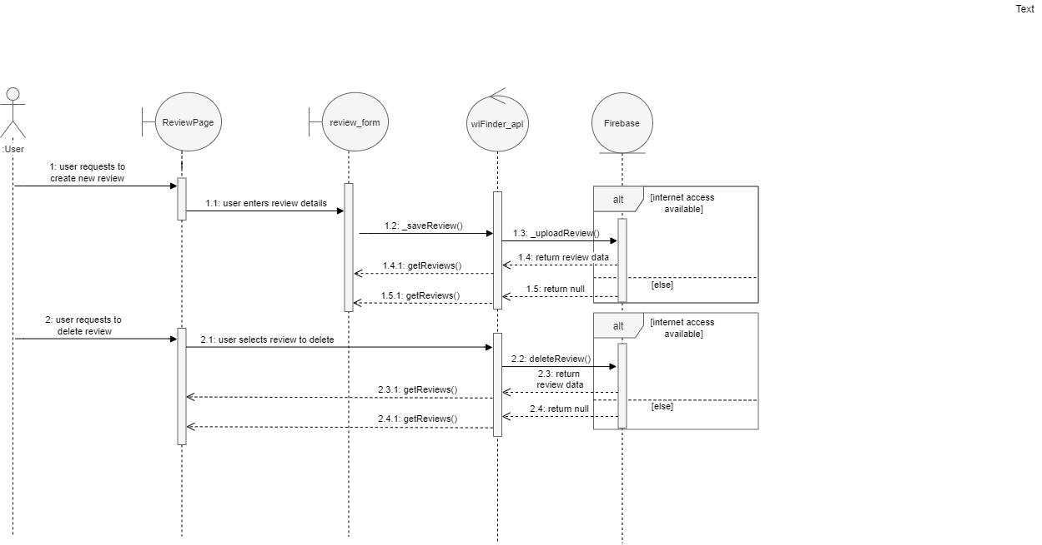

|  |  |
| --- | --- |
| **Stimulus** | **Response** |
| User requests to add new review | * The application will display a review form for the user to enter his/her review. * The system will add the new review to the review list and display the updated list. |
| User requests to delete own review | * The system will remove the selected review and display the updated list. |

### 4.5.3 Functional Requirements

|  |  |
| --- | --- |
| REQ 5-1:  Internet Access | 1. Internet access is required to manage reviews and ratings. 2. If there is no internet access, reviews and ratings will not be saved. |
| REQ 5-2:  Managing reviews and ratings | 1. The user should be able to make changes to their own reviews and ratings of a Wi-Fi hotspot.   Changes include:   1. Adding a review and rating 2. Editing a review and rating 3. Deleting a review and rating |

# 5. Other Nonfunctional Requirements

## 5.1 Performance Requirements

1. The system must not crash during the use of the application.
2. The system must be able to update the user’s location in real time with the presence of an internet connection.
3. The system must be able to return the display results to the user within 2 seconds.

## 5.2 Safety Requirements

1. The application does not have an external device that may harm the life of the user. However, users are advised to remain alert when using the navigation function to proceed to a Wi-Fi hotspot to avoid unnecessary accidents while using the application.

## 5.3 Security Requirements

1. The system must secure any personal data that the user provides such as login credentials.
2. The system must ensure that details from one user are not tampered with by another user such as inputs in ratings and reviews.

## 5.4 Software Quality Attributes

### 5.4.1 Reliability

1. The system should display data accurately.
2. The system should be fully functional after the application has been restarted.

### 5.4.2 Usability

1. The system must be efficient.
2. Users should be able to reach their goal in a minimal number of steps.
3. The system must be easily learnable.
4. Display should be kept simple for an intuitive experience.

### 5.4.3 Recoverability

1. In the event of a bug/app failure, the system must be able to regain its full functionality after maintenance.

### 5.4.5 Display

1. The system should reflect the user’s input and changes
2. Input like:
3. Searching
4. Bookmark a Wi-Fi hotspot as a favourite
5. Changes such as
6. Sorting
7. Filtering
8. The system should display default preferences
9. Default should be nearby Wi-Fi hotspots
10. Each Wi-Fi hotspot should display the following:
11. Address
12. Favourite
13. Average Ratings
14. Access Information
15. Redirect to Google Maps

# Appendix A: Requirements Analysis

## I. Use Case Diagram

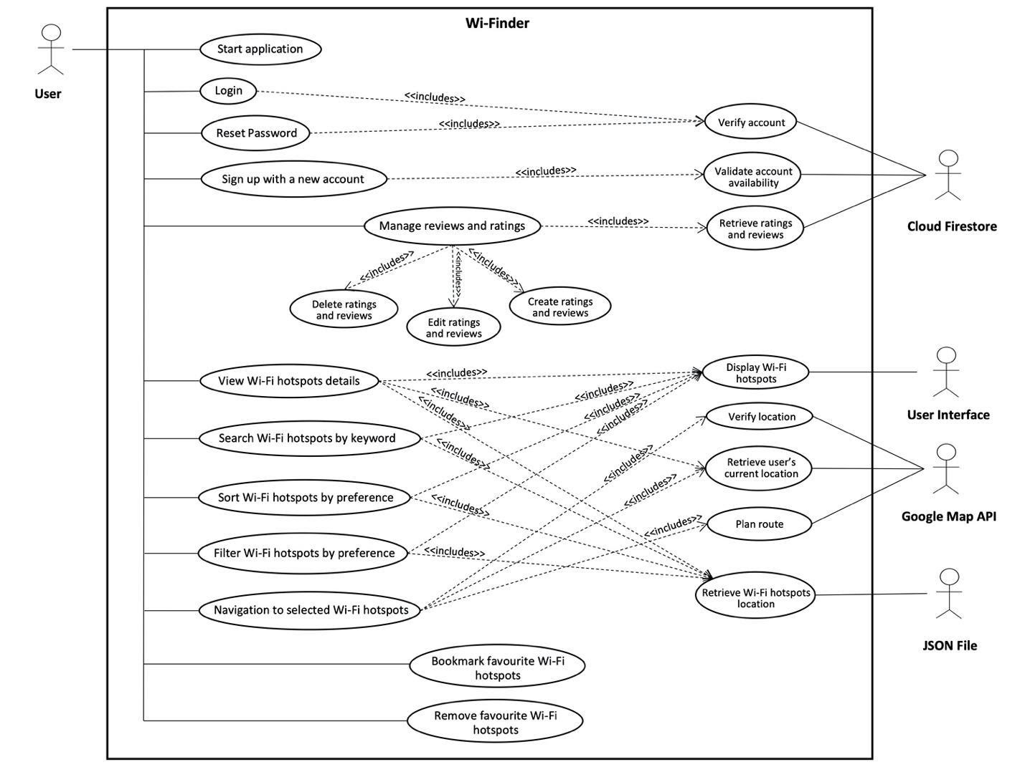

## II. Use Case Description

|  |  |  |  |
| --- | --- | --- | --- |
| Use Case ID: | 1 | | |
| Use Case Name: | Start Application | | |
| Created By: | Chong You Min | Last Updated By: | Chong You Min |
| Date Created: | 4 February 2020 | Date Last Updated: | 5 February 2020 |

|  |  |
| --- | --- |
| Actor: | User |
| Description: | User starts application from user dashboard. |
| Preconditions: | 1. Application must be installed and downloaded to the user’s mobile device. |
| Postconditions: | 1. Application successfully starts/fails to start. |
| Priority: | High |
| Frequency of Use: | 0 – 10 times per day |
| Flow of Events: | 1. User runs the application. 2. System runs and displays the application loading page. |
| Alternative Flows: | - |
| Exceptions: | EX1: User fails to start the application.   1. System exits. |
| Includes: | - |
| Special Requirements: | 1. Application should not freeze and crash. 2. Application should be responsive. 3. Application’s full functionalities must be restored after application reset. |
| Assumptions: | 1. Users use the application to find Wi-Fi hotspots according to their preference. |
| Notes and Issues: | - |

|  |  |  |  |
| --- | --- | --- | --- |
| Use Case ID: | 2 | | |
| Use Case Name: | Login | | |
| Created By: | Chong You Min | Last Updated By: | Chong You Min |
| Date Created: | 30 March 2020 | Date Last Updated: | 30 March 2020 |

|  |  |
| --- | --- |
| Actor: | User |
| Description: | User can login with an account to access the functionalities of the application. |
| Preconditions: | 1. Application successfully started. 2. User needs to be connected to the internet. 3. User account must exist in the cloud database to login. |
| Postconditions: | 1. User logged in successfully. |
| Priority: | High |
| Frequency of Use: | 1 - 3 times per lifetime |
| Flow of Events: | 1. User requests to login. 2. User enters the verified email address and password to login. 3. User submits login details. 4. System validates the account by checking the data entered by the user, with the cloud database. 5. System authenticates the user to login successfully. |
| Alternative Flows: | AF-S4: User enters wrong credentials.   1. System will prompt the user to re-enter their email address and password to login. 2. Return to Step 2. |
| Exceptions: | EX1: System fails to call back-end application to process/retrieve the relevant data.   1. System will prompt the user to reopen the application. |
| Includes: | 1. Verify User Account. |
| Special Requirements: | - |
| Assumptions: | - |
| Notes and Issues: | - |

|  |  |  |  |
| --- | --- | --- | --- |
| Use Case ID: | 3 | | |
| Use Case Name: | Sign Up With a New Account | | |
| Created By: | Chong You Min | Last Updated By: | Chong You Min |
| Date Created: | 30 March 2020 | Date Last Updated: | 1 April 2020 |

|  |  |
| --- | --- |
| Actor: | User |
| Description: | User can sign up with a new account to access the functionalities of the application. |
| Preconditions: | 1. Application successfully started. 2. User needs to be connected to the internet. 3. User needs to have a valid email address that does not exist in the cloud database to create a new account. |
| Postconditions: | 1. User account created successfully. 2. User can login with the new account. |
| Priority: | High |
| Frequency of Use: | 1 - 3 times per lifetime |
| Flow of Events: | 1. User requests to create a new account. 2. User enters a display name. 3. User provides a valid email address as authentication. 4. User enters a password. 5. User confirms password. 6. User submits the sign up form. 7. System calls firebase SMTP to send a verification email to the email address user provided. 8. User clicks on the verification link. 9. User can login with the new account. |
| Alternative Flows: | AF-S6: User provided an invalid email address.   1. System will prompt the user to enter a valid email address. 2. Return to Step 3.   AF-S6: User’s password does not contain one special character and one symbol.   1. System will prompt the user to enter another password. 2. Return to Step 4.   AF-S6: User’s password and confirm password does not match.   1. System will prompt the user to re-enter confirm password that matches the password. 2. Return to Step 5. |
| Exceptions: | EX1: System fails to call back-end application to process/retrieve the relevant data.   1. System will prompt the user to reopen the application. |
| Includes: | 1. Validate Account Availability. |
| Special Requirements: | 1. System should be able to retrieve and process data within 20 seconds. |
| Assumptions: | - |
| Notes and Issues: | - |

|  |  |  |  |
| --- | --- | --- | --- |
| Use Case ID: | 4 | | |
| Use Case Name: | Verify User Account | | |
| Created By: | Chong You Min | Last Updated By: | Chong You Min |
| Date Created: | 31 March 2020 | Date Last Updated: | 31 March 2020 |

|  |  |
| --- | --- |
| Actor: | System |
| Description: | System to verify user account validity. |
| Preconditions: | 1. User needs to be connected to the internet. 2. User account must exist in the cloud database. |
| Postconditions: | 1. User account will be verified to perform a login or reset password. |
| Priority: | High |
| Frequency of Use: | 1 - 3 times per lifetime |
| Flow of Events: | 1. User selects to login or reset password. 2. User enters credentials. 3. User submits credentials. 4. System verifies the account validity in the cloud database. 5. System authenticates the user to login successfully or directs user to reset password. |
| Alternative Flows: | AF-S3: System detects that account does not exist in the cloud database.   1. System will prompt the user to re-enter email address. 2. Return to Step 2. |
| Exceptions: | EX1: System fails to call back-end application to process/retrieve the relevant data.   1. System will prompt the user to reopen the application. |
| Includes: | - |
| Special Requirements: | - |
| Assumptions: | - |
| Notes and Issues: | - |

|  |  |  |  |
| --- | --- | --- | --- |
| Use Case ID: | 5 | | |
| Use Case Name: | Validate Account Availability | | |
| Created By: | Chong You Min | Last Updated By: | Chong You Min |
| Date Created: | 30 March 2020 | Date Last Updated: | 30 March 2020 |

|  |  |
| --- | --- |
| Actor: | System |
| Description: | System to validate account availability, send verification email to email address provided by user, and create the user account. |
| Preconditions: | 1. User needs to be connected to the internet. 2. User needs to have a valid email address that does not exist in the cloud database to create a new account. |
| Postconditions: | 1. User account successfully created in the cloud database. 2. User will be able to login using the registered account. |
| Priority: | High |
| Frequency of Use: | 1 - 3 times per lifetime |
| Flow of Events: | 1. User selects to create a new account. 2. User enters credentials. 3. User submits credentials. 4. System validates the account availability in the cloud database. 5. System calls firebase SMTP to send verification email to user. 6. User clicks on verification link. 7. System creates the user account in the cloud database. |
| Alternative Flows: | AF-S3: System detects that account does not exist in the cloud database.   1. System will prompt the user to re-enter email address. 2. Return to Step 2. |
| Exceptions: | EX1: System fails to call back-end application to process/retrieve the relevant data.   1. System will prompt the user to reopen the application. |
| Includes: | - |
| Special Requirements: | - |
| Assumptions: | - |
| Notes and Issues: | - |

|  |  |  |  |
| --- | --- | --- | --- |
| Use Case ID: | 6 | | |
| Use Case Name: | Reset Password | | |
| Created By: | Chong You Min | Last Updated By: | Chong You Min |
| Date Created: | 31 March 2020 | Date Last Updated: | 31 March 2020 |

|  |  |
| --- | --- |
| Actor: | User |
| Description: | User can reset their account password. |
| Preconditions: | 1. User needs to be connected to the internet. 2. User email address must exist in the cloud database to reset their password. |
| Postconditions: | 1. Password successfully reset. 2. User will be able to login using the new password. |
| Priority: | High |
| Frequency of Use: | 0 - 4 times per lifetime |
| Flow of Events: | 1. User selects the “forget password” feature. 2. System will prompt the user to enter their email address. 3. User enters email address. 4. User submits email address. 5. System calls firebase SMTP to send an email to the user, providing a link that directs the user to change password. 6. User clicks on the link. 7. System directs user to enter a new password. 8. User enter a new password. 9. User submits new password. 10. System updates the user account password with the new password. 11. User can login using the new password. |
| Alternative Flows: | AF-S4: System detects that account does not exist in the cloud database.   1. System will prompt the user to re-enter email address. 2. Return to Step 3. |
| Exceptions: | EX1: System fails to call back-end application to process/retrieve the relevant data.   1. System will prompt the user to reopen the application. |
| Includes: | 1. Verify Account. |
| Special Requirements: | - |
| Assumptions: | - |
| Notes and Issues: | - |

|  |  |  |  |
| --- | --- | --- | --- |
| Use Case ID: | 7 | | |
| Use Case Name: | View Wi-Fi Hotspot Details | | |
| Created By: | Chong You Min | Last Updated By: | Chong You Min |
| Date Created: | 4 February 2020 | Date Last Updated: | 13 April 2020 |

|  |  |
| --- | --- |
| Actor: | User |
| Description: | User requests to view selected Wi-Fi hotspot details. |
| Preconditions: | 1. User must be logged in. 2. User needs to be connected to the internet to retrieve reviews and ratings. |
| Postconditions: | 1. System displays relevant reviews and ratings, access information, and address of the selected Wi-Fi hotspot. |
| Priority: | High |
| Frequency of Use: | 0 – 10 times per day |
| Flow of Events: | 1. System triggers retrieve user’s current location use case. 2. System triggers retrieve Wi-Fi hotspots location use case. 3. System triggers display Wi-Fi hotspots use case. 4. System displays Wi-Fi hotspots near the user’s current location after retrieving relevant information. 5. User selects a particular pin on the map or hotspot in the hotspot list. 6. System retrieves reviews and ratings, access information, and address of the selected Wi-Fi hotspot. 7. System displays access information and address of the selected Wi-Fi hotspot. |
| Alternative Flows: | AF-S2: System fails to retrieve user’s current location.   1. System displays all Wi-Fi hotspots available. 2. Return to Step 1. |
| Exceptions: | EX-AF-S2: System fails to detect user’s current location.   1. System will prompt the user to reopen the application. |
| Includes: | 1. Display Wi-Fi hotspots. 2. Retrieve user’s current location. 3. Retrieve Wi-Fi hotspots location. |
| Special Requirements: | 1. System should display all available Wi-Fi hotspots information accurately. |
| Assumptions: | - |
| Notes and Issues: | - |

|  |  |  |  |
| --- | --- | --- | --- |
| Use Case ID: | 8 | | |
| Use Case Name: | Search Wi-Fi Hotspot by Keyword | | |
| Created By: | Chong You Min | Last Updated By: | Chong You Min |
| Date Created: | 4 February 2020 | Date Last Updated: | 30 March 2020 |

|  |  |
| --- | --- |
| Actor: | User |
| Description: | To search for Wi-Fi hotspots in the database based on search input provided by the user. |
| Preconditions: | 1. List of all available Wi-Fi hotspots must be retrieved in order to perform search. |
| Postconditions: | 1. A list of available Wi-Fi hotspots that satisfies the given input will be displays to the user. |
| Priority: | High |
| Frequency of Use: | 0 – 10 times per day |
| Flow of Events: | 1. User requests to perform a search. 2. User enters a location name into the system. 3. User submits the search request into the system. 4. System displays a list of Wi-Fi hotspots that satisfies the user’s input. |
| Alternative Flows: | AF-S3: User enters an invalid location name.   1. System will not display any Wi-Fi hotspots. 2. Return to Step 2. |
| Exceptions: | - |
| Includes: | 1. Display Wi-Fi hotspots. 2. Retrieve Wi-Fi hotspots location. |
| Special Requirements: | 1. System should rank and display search results from the nearest to the furthest of the user’s input location. 2. System should display Wi-Fi hotspots information accurately. 3. System must display the search result to the user within 2 seconds. |
| Assumptions: | - |
| Notes and Issues: | - |

|  |  |  |  |
| --- | --- | --- | --- |
| Use Case ID: | 9 | | |
| Use Case Name: | Sort Wi-Fi Hotspots by Preference | | |
| Created By: | Chong You Min | Last Updated By: | Chong You Min |
| Date Created: | 4 February 2020 | Date Last Updated: | 6 February 2020 |

|  |  |
| --- | --- |
| Actor: | User |
| Description: | Sort all available Wi-Fi hotspots based on user’s selection. |
| Preconditions: | 1. List of all available Wi-Fi hotspots must be retrieved in order to be sorted. |
| Postconditions: | 1. System displays the sorted list of Wi-Fi hotspots, based on the user’s selection. |
| Priority: | Medium |
| Frequency of Use: | 0 – 20 times per day |
| Flow of Events: | 1. User requests to sort all Wi-Fi hotspots. 2. User selects preferred sorting choice. 3. System displays a list of hotspots based on the user’s preferred sorting choice. |
| Alternative Flows: | - |
| Exceptions: | - |
| Includes: | 1. Display Wi-Fi hotspots. 2. Retrieve Wi-Fi hotspots location. |
| Special Requirements: | 1. System should display Wi-Fi hotspots information accurately. 2. System must display the search result to the user within 2 seconds. |
| Assumptions: | - |
| Notes and Issues: | - |

|  |  |  |  |
| --- | --- | --- | --- |
| Use Case ID: | 10 | | |
| Use Case Name: | Filter Wi-Fi Hotspots by Preference | | |
| Created By: | Chong You Min | Last Updated By: | Chong You Min |
| Date Created: | 4 February 2020 | Date Last Updated: | 25 March 2020 |

|  |  |
| --- | --- |
| Actor: | User |
| Description: | Filter all available Wi-Fi hotspots based on user’s selection. |
| Preconditions: | 1. List of all available Wi-Fi hotspots must be retrieved in order to be filtered. |
| Postconditions: | 1. System displays the filtered list of Wi-Fi hotspots, based on the user’s selection. |
| Priority: | Medium |
| Frequency of Use: | 0 – 20 times per day |
| Flow of Events: | 1. User requests to filter Wi-Fi hotspots. 2. User selects preferred filter choice. 3. System displays a list of hotspots based on the user’s preferred filter choice. |
| Alternative Flows: | - |
| Exceptions: | - |
| Includes: | 1. Display Wi-Fi hotspots. 2. Retrieve Wi-Fi hotspots location. |
| Special Requirements: | 1. System should display Wi-Fi hotspots information accurately. 2. System must display the search result to the user within 2 seconds. |
| Assumptions: | - |
| Notes and Issues: | - |

|  |  |  |  |
| --- | --- | --- | --- |
| Use Case ID: | 11 | | |
| Use Case Name: | Navigation to Selected Wi-Fi Hotspot | | |
| Created By: | Chong You Min | Last Updated By: | Goh Jia Hui |
| Date Created: | 4 February 2020 | Date Last Updated: | 6 February 2020 |

|  |  |
| --- | --- |
| Actor: | User |
| Description: | User requests for navigation instructions to selected Wi-Fi hotspot location. |
| Preconditions: | 1. User needs to be connected to the internet. 2. User’s current location and relevant information must be available for retrieval. |
| Postconditions: | 1. System redirects the user to Google Maps for navigation instructions to their selected Wi-Fi hotspot location. |
| Priority: | Medium |
| Frequency of Use: | 0 – 5 times per day |
| Flow of Events: | 1. User selects a Wi-Fi hotspot from the map or in the list. 2. User selects the navigation feature. 3. System triggers retrieve user’s current location use case. 4. System triggers verify location use case. 5. System triggers plan route use case. 6. System redirects the user to Google Maps for navigation. |
| Alternative Flows: | AF-S6: Google Maps is not the default mapping application.   1. System display pop-up message to select preferred mapping application. |
| Exceptions: | EX1: Google Maps API failed to detect if the user is connected to the internet.   1. System is unable to plan route using Google Maps API.   EX2: Google Maps API failed to detect user’s current location.   1. System is unable to plan route using Google Maps API. |
| Includes: | 1. Verify Location. 2. Retrieve User’s Current Location. 3. Plan Route. |
| Special Requirements: | 1. System have to be able to direct user to Google Maps for navigation within 2 seconds. |
| Assumptions: | - |
| Notes and Issues: | - |

|  |  |  |  |
| --- | --- | --- | --- |
| Use Case ID: | 12 | | |
| Use Case Name: | Manage Reviews & Ratings for Wi-Fi Hotpots | | |
| Created By: | Chong You Min | Last Updated By: | Chong You Min |
| Date Created: | 4 February 2020 | Date Last Updated: | 1 April 2020 |

|  |  |
| --- | --- |
| Actor: | User |
| Description: | To create, delete, edit, and update reviews and ratings for a Wi-Fi hotspot. |
| Preconditions: | 1. User needs to be connected to the internet. 2. A Wi-Fi hotspot must be selected. |
| Postconditions: | 1. Review and rating will be created, edited, deleted, and updated in real time based on user’s selection. |
| Priority: | Medium |
| Frequency of Use: | 0 – 5 times per day |
| Flow of Events: | 1. User selects a Wi-Fi hotspot on the map or in the list. 2. User selects add review and rating feature. 3. System directs the user to create a new review and rating for the selected Wi-Fi hotspot. 4. User fills in respective fields. 5. User submits a review and rating. 6. System updates the reviews and ratings database of the selected Wi-Fi hotspot with the newly added review. 7. System retrieves the list of reviews and ratings for the Wi-Fi hotspot. 8. System displays the list of reviews and ratings for the hotspot. 9. User selects a review and rating to delete from the selected Wi-Fi hotspot. 10. User selects the delete review and rating feature. 11. User confirms deletion. 12. System deletes the selected review and rating from the database of the selected Wi-Fi hotspot. 13. System updates the reviews and ratings database of the selected Wi-Fi. 14. System retrieves the list of reviews and ratings for the Wi-Fi hotspot. 15. System displays the list of reviews and ratings for the hotspot. 16. User selects a review and rating to edit from the selected Wi-Fi hotspot. 17. User selects the edit review and rating feature. 18. User edits fields. 19. User submits the review and rating when editing is done. 20. System updates the reviews and ratings database of the selected Wi-Fi. 21. System retrieves the list of reviews and ratings for the Wi-Fi hotspot. 22. System displays the list of reviews and ratings for the hotspot. |
| Alternative Flows: | AF-S5: System detects that not all fields are completed.   1. System prompts user to complete incomplete fields. 2. Return to Step 4.   AF-S9: User selects a wrong review and rating to delete.   1. User submits a request to be directed back to the previous page. 2. System directs user back to the previous page. 3. Return to Step 9.   AF-S16: User selects a wrong review and rating to edit.   1. User submits a request to be directed back to the previous page. 2. System directs user back to the previous page. 3. Return to Step 16. |
| Exceptions: | - |
| Includes: | 1. Create Ratings and Reviews. 2. Edit Ratings and Reviews. 3. Delete Ratings and Reviews 4. Retrieve Ratings and Reviews. |
| Special Requirements: | 1. Reviews and ratings database should be updated in real time. 2. System must secure any personal data that the user provides. |
| Assumptions: | 1. Users do not abuse our application platform by creating false reviews and ratings. |
| Notes and Issues: | - |

|  |  |  |  |
| --- | --- | --- | --- |
| Use Case ID: | 13 | | |
| Use Case Name: | Bookmark Favourite Wi-Fi Hotspots | | |
| Created By: | Chong You Min | Last Updated By: | Chong You Min |
| Date Created: | 4 February 2020 | Date Last Updated: | 25 March 2020 |

|  |  |
| --- | --- |
| Actor: | User |
| Description: | User will be able to bookmark their favourite Wi-Fi hotspots. |
| Preconditions: | 1. User needs to be connected to the internet. 2. List of all available Wi-Fi hotspots must be retrieved in order to select a Wi-Fi hotspot to favourite. |
| Postconditions: | 1. User’s favourite Wi-Fi hotspots will be stored in the mobile local storage. |
| Priority: | Medium |
| Frequency of Use: | 0 – 10 times per day |
| Flow of Events: | 1. User selects a Wi-Fi hotspot on the map or in the list. 2. User bookmarks the Wi-Fi hotspot as a favourite. 3. System stores the Wi-Fi hotspot in the mobile’s local storage. 4. System updates the list of the user’s favourite Wi-Fi hotspots. 5. System retrieves the list of user’s favourite Wi-Fi hotspots. 6. System displays the list of user’s favourite Wi-Fi hotspots. |
| Alternative Flows: | - |
| Exceptions: | - |
| Includes: | - |
| Special Requirements: | - |
| Assumptions: | - |
| Notes and Issues: | - |

|  |  |  |  |
| --- | --- | --- | --- |
| Use Case ID: | 14 | | |
| Use Case Name: | Remove Favourite Wi-Fi Hotspots | | |
| Created By: | Goh Jia Hui | Last Updated By: | Goh Jia Hui |
| Date Created: | 4 February 2020 | Date Last Updated: | 5 February 2020 |

|  |  |
| --- | --- |
| Actor: | User |
| Description: | User will be able to remove Wi-Fi hotspots they have previously bookmarked as a favourite Wi-Fi hotspot. |
| Preconditions: | 1. User needs to be connected to the internet. 2. User must have at least one Wi-Fi hotspot bookmarked as a favourite. |
| Postconditions: | 1. Selected Wi-Fi hotspots will be from the user’s favourite list. |
| Priority: | Medium |
| Frequency of Use: | 0 – 10 times per day |
| Flow of Events: | 1. User selects a Wi-Fi hotspot from the list of favourites. 2. User removes the Wi-Fi hotspot as a favourite. 3. System updates the list of the user’s favourite Wi-Fi hotspots. 4. System retrieves the list of user’s favourite Wi-Fi hotspots. 5. System displays the list of user’s favourite Wi-Fi hotspots. |
| Alternative Flows: | - |
| Exceptions: | - |
| Includes: | - |
| Special Requirements: | - |
| Assumptions: | - |
| Notes and Issues: | - |

# Appendix B: Analysis Models

## I. Class diagram

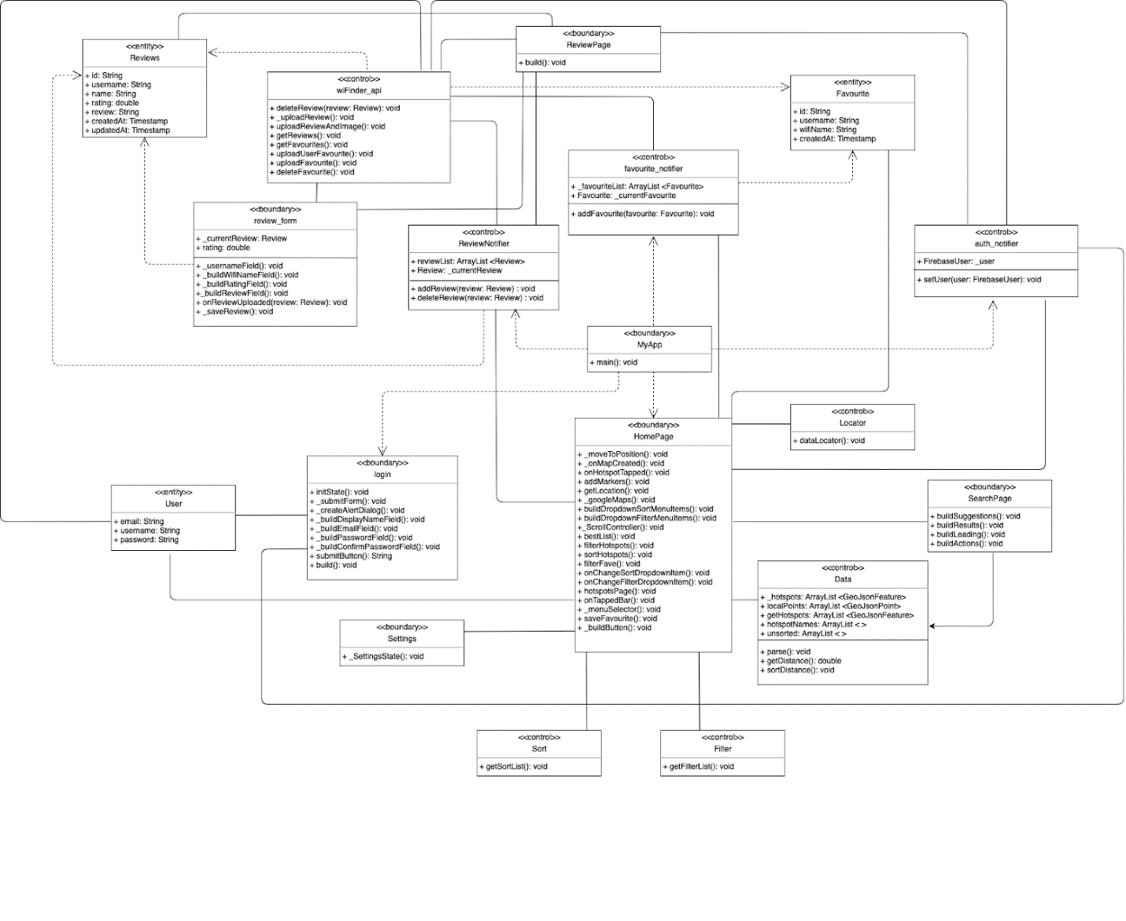

## II. Dialog map

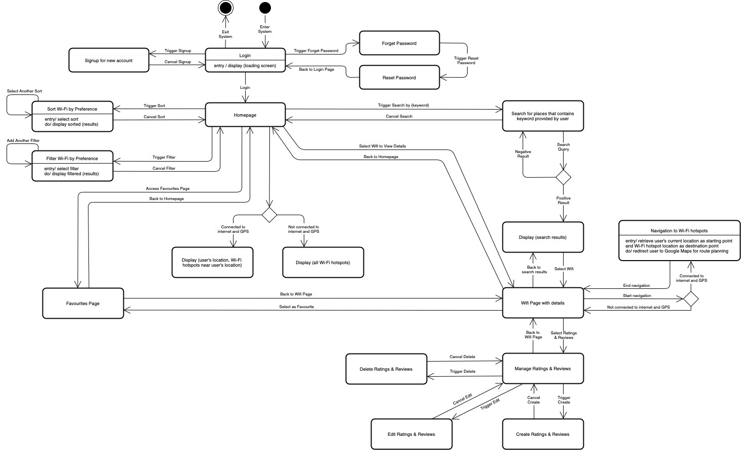

**III. System Architecture**

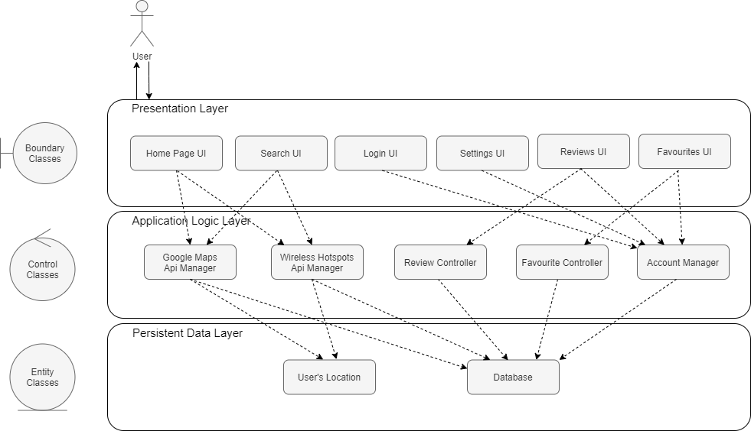

# Appendix C: File References

## I. Source Code and APK

The source code is exported as a zip file named Wi-Finder – Source Code.zip.

Wi-Finder android app is exported as an APK file named Wi-Finder.apk.

## II. Demo Video

The video demonstration is saved under the video file named Demo Video.mp4

## III. All Diagrams

All other diagrams can be found in the folder named Diagrams and Files Meeting Minutes

## IV. Final Presentation

Slides can be found under the file Final Presentation.pdf